Joyful Notes

April 2011

“Open Hearts. Open Minds. Open Doors”

LIFE OF OUR CHURCHES…

Astoria and Warrenton United Methodist Churches
Pastor: Rev. Judy Johnson Diaconal Minister: Jane Hill
Administrative assistant: Linda Grznar



Jennifer Mercer to be named as new pastor in Astoria
While not official until Annual Conference in June, it is the Bishop’s intention to name Jennifer Mercer as Astoria’s new pastor. Please see the letter on page 3 of this issue for more information. The SPRC will be meeting over the next several months to help welcome Jennifer and make the transition as smooth as possible. Please keep Jennifer, this community of faith and the process in prayer.

What’s Happening in Warrenton?
The community of faith at Warrenton has come to the difficult realization that they cannot continue as the church they are now. Talks are beginning with Astoria First UMC to see if merger is a possibility. Please keep Warrenton and this process in prayer.

Open Meeting to discuss possible merger, April 2, 10 am in Warrenton
Members and friends of both the Warrenton and Astoria churches are invited to an open meeting on Saturday, April 2 at 10 am to discuss how we can join together to be a United Methodist presence in this part of God’s kingdom. How can we be in ministry with the people and needs around us with the people and resources we have? What would it look like to have our two churches working together as one new church? We need dreaming ideas and reality questions. Please write down your thoughts and concerns before the meeting. Come open to God surprising us with new ideas that may challenge our assumptions of what merger will look like. This is the beginning of a process. After more discussions, each church will have a charge conference to vote on the merger. Please hold this process in prayer.

Holy Week
April 17, Palm Sunday: 9 am, Warrenton and 11 am, Astoria
April 21, Joint Maundy Thursday Soup Supper and Communion Service, 5:30 pm, Warrenton UMC
April 22, Ministerial Association Good Friday Service, noon, place to be announced
April 24, Easter “Sunrise” Service, 7 am, Astoria Column (Hilltop Nazarene Church if raining)
Easter services: 9 am, Warrenton and 11 am, Astoria

One Great Hour of Sharing, April 3
On the first Sunday in Lent (March 13) a special Lenten Stewardship prayer and giving calendar was given out. The suggestions for prayer and giving are based on the many blessings you have in your life. The money earned as you pray your way through the calendar will go to the One Great Hour of Sharing offering. This annual special offering supports the work of UMCOR, United Methodist Committee on Relief, which is our disaster relief agency. This money allows every dollar that is donated for disaster relief to go directly to the disaster relief that people need. Please bring your special offering to worship April 3. If you did not receive the prayer and giving calendar, please contact the office.

Meals for Circle of Security continue. Thank you to all who are helping with this ministry to families. Check with Anne Morden if you have any questions. Thank you to Sue Hicks, Jane Hill, Elizabeth Mannarino and Joanne Soderman for March meals.

April’s volunteers are
April 7 The Albrights April 21
April 14 Jane Hill April 28 Sue Hicks

Please call the office if you can help on the 21^{st.}. THANKS!

Please Pray for
- All with health concerns and Jean Curry, Rachael, Audrey Paetow, Jean Curry, Dave Kinman, Dorothy Lindstrom, Gladys Dyer, George and Helen Gunn, Joanne Soderman, Denny Jr.,Yvonne Comins, Bernice Winn, Nettie Blair, Alicia Hess, Dr. and Mary Kettlekamp, Rae Estes, Carol Boothe, Trudy Anglim, Sharon Kastl, Laurel Nichols, Bill and Edna Leonard, Charlotte Patching, Jim Swanson, Diane Curs, Mary Ann and Antti Ylipelto, Tom Dyer, Norman Doney, Sharon Wolf, Maxine Dymond, Bruce Dymond, Pam Jenkins, Scott Kindred, Charlie and Nellie Hansen, Bob and Ginnie Tate, Pat Kujala, Carol Clark, Delores Hodney, Joy, Jeff, Jessica and Joseph, Ginny Bynum, Verna Davis, Elizabeth Mannarino, Jewell Smotherman, Rose Marie Thompson. All who are ill and their families.
- All who are mourning including the families of Alvin Holdiman and Don Hartill
- Families who need reconciliation
- Our churches during this time of transition. Pray for Jennifer and for the church in this in-between time of now and her arrival. Pray for patience and hope, awareness of the stress of change, and openness to the new opportunities to be in ministry with our communities. Pray for Kate, the Bishop and the Cabinet.
- Pray for the people of Japan. Pray for relief workers and service dogs and all others who are overwhelmed and tired.
- People and churches in transitions. People who have lost their jobs, homes, life savings, self-worth.
- All who are serving our country. Prayers for Laura Hutson’s daughter, Ada, and Jim and Vera Spain’s grandson, Chris, being deployed soon.
- New parents, single parents, all parents and children. Pray for Circle of Security.
- The hungry, the homeless, those in prison, those living in violence, those with addictions and their families.
- Pray for your neighbors and your enemies.

Special People
- Congratulations to four United Methodist Women and 96 others who were recognized by AAUW (American Association of University Women) as part of their listing of 100 Significant Women in Astoria history in preparation for Astoria’s bicentennial:
Bev Cox, Anne Morden, Jane Hill and Vera Gault. We are proud of you!!
- Those who helped clean the Astoria church on the March 19th workday.
- Rev. Ev Erbele, who traveled form Alaska to tell us about the mission church she and her husband serve in Alaska. We have a covenant relationship with them.
- All who contributed to the itineration fund that helps pay the travel expenses for Ev Erbele and other missionaries as they visit churches in our conference.
- All who contributed to the eyeglasses fund for one of Mindy’s students. Your generosity is AWESOME. Thank you.
- Matt Patterson who undertook a bike ride from San Diego to South Carolina to honor his sister Arlene and to benefit hospice. Donations may be made to hospice in his sister’s name.

Letter read at Astoria worship March 13, 2011

March 13, 2011

Dear Members and Friends of Astoria First United Methodist Church,

Greetings in the name of our Lord Jesus Christ!

First of all, I need to say this – I am a huge fan of your pastor, the Rev. Judy Johnson. She embodies the love and the inclusive heart of Jesus. She is a great gift, not only to the congregation but to the Astoria community as well. With her leadership, the congregation has become a place where all are truly welcome. There is an increased sense of being in mission to the community. I celebrate the six years of Judy’s ministry among you. I know that you will find ways to express your appreciation for her and her ministry between now and her retirement on June 30th.

I had the privilege of being in worship with you last December, followed by a conversation about the mission and ministry of the congregation. I was blown away by what I experienced and heard. I felt the energy and passion around ministry to the Astoria community. I witnessed the capacity to open your arms and hearts to folk of all ages and life situations. When I was sharing my excitement with the bishop and cabinet, I said I believed Astoria, in partnership with the right next pastor, could build on Judy’s outstanding ministry and continue on a path of renewed health and vitality.

Two Holy Spirit gifts came next. After a prayer of discernment, the cabinet chose as our candidate for Astoria one of our most gifted and high potential clergy for church revitalization, Jennifer Mercer. She is currently the pastor at Vale and Ontario United Methodist Churches. Next, my colleagues around the cabinet table authorized me to use conference funds to make Astoria a full time position for this next appointment year, with plans for future funding if all goes as we believe it will. We want to maximize your potential for revitalization. This will mean an increasingly outward focus on the many places of need in the community, while providing a place of vital worship and nurture as disciples of Jesus Christ.

Jennifer, who grew up in Arlington, Virginia, has lived for the last twelve years in the Boise area. She has a professional background in banking and as an Information Technology specialist for the State of Idaho. Jennifer, who is a lifelong United Methodist, started working in the church directing the children’s choir and as a Director of Music. While still a full time state employee, Jennifer was on staff at Nampa First UMC as their worship coordinator. Her portfolio included starting a contemporary worship service, which involved the utilization of graphics and sound technology to enhance the service. Jennifer, who loves to bring folk together for worship, also started a new worship service for the developmentally challenged and their families. She believes that having a younger sister with Downs Syndrome gave her a heart for the marginalized and those at the fringes of society at a very early age.

Jennifer met with the Staff Parish Relations committee on Friday, along with Marla, Josh, Claire and Abby, who were wonderful additions to our gathering. After a time of meeting together, both Jennifer and the committee gave an enthusiastic “yes” to my question of whether we could move forward with this appointment. Consequently, it is the intention of Bishop Robert Hoshibata to appoint Jennifer Mercer as your new pastor, effective July 1. I am thrilled and look forward to seeing what this partnership will bring!

I would ask you to hold both Judy and Jennifer in prayer as they move through their respective transitions. I am praying for them and for all of you as well. I thank God for your huge hearts and your deep faith.

So blessed to be in ministry with you,

Kate Conolly
Assistant to the Bishop for the Western District

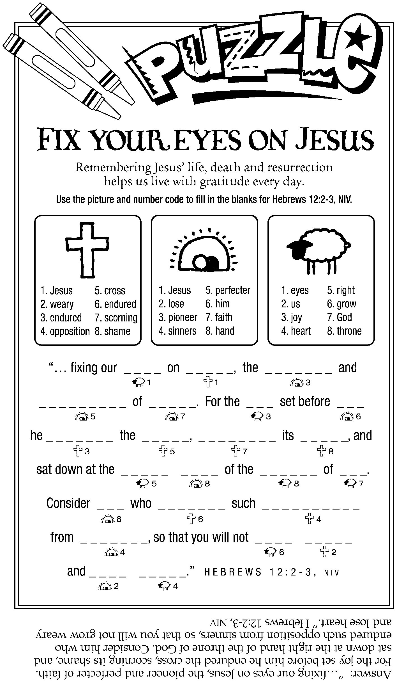

Day Camp meeting, April 17
After worship in Astoria on Palm Sunday, April 17, we will have a Day Camp meeting. At our last meeting, we decided to continue holding the day camp at Shively Park. Dates are August 15-18.
Please pray for the children, volunteers and supporters in this outreach ministry with children.

Easter Offering
The Astoria church has designated the special Easter offering go to UMCOR for the disaster relief in Japan. Please keep all affected by this disaster in your prayers.

Raise the Roof – thoughts from Judy

Have you ever noticed how things come in threes? Life seems to challenge us in clusters. One challenge is enough. But three? Or more? We seem to be in a clustered challenge time. Disasters around the world. A new pastor. Possible merger. Financial concerns. Your own health and family situations. The list goes on. How long, O God?

Many of you received a letter asking for financial support for the new roof that is desperately needed in Astoria. And I know that some of you may have reacted negatively. I can hear you say: I gave to the Stuff the Turkey campaign. I pledged. I’ll be giving to the One Great Hour of Sharing offering. I gave to the itineration fund. And now they want more?!!!!

I give a big sigh as I write this. I am praying about how much I will give to the Raise the Roof campaign. Like you I struggle with how much money can I give away and how much do I keep for myself. It is true my checkbook reflects my priorities. I write lots of checks for household expenses, lots for food related expenses and the car. I find myself saying the church is important to me also: The outreach to help others through the food bank, UMCOR, Pennies for Peace. The ability to worship in a meaningful way. The desire to have a warm, inviting and functional building that is in good repair.

We invite you to prayerfully give as generously as you can. We understand that you may not be able to give money on April 3. However, we need some sense of how much money we will need to seek outside the church. Please feel free to pledge your support. We ask, if possible, that you give that amount by the beginning of June. I know some will be able to use their tax refund this way.

Thank you for your generosity.

Since I am who I am, I would be remiss if I did not point out one cluster of three that provides us blessing upon blessing: God who is Trinity. God who is Creator, Redeemer and Sustainer. God who freely and abundantly gives us peace, healing, forgiveness, grace, love and redemption through Christ.

In response to God’s blessings,
I commit to give $_________ for the
Raise the Roof Campaign.
(I understand it is to be paid by June 3.)

Name_______________________________

If you are unable to be in worship April 3, please mail to
Astoria First United Methodist Church

1076 Franklin Ave
Astoria, OR 97103

