Joyful Notes

December 2009

“Open Hearts. Open Minds. Open Doors”

LIFE OF OUR CHURCHES…

Astoria and Warrenton United Methodist Churches
Pastor: Rev. Judy Johnson, Diaconal Minister: Jane Hill





How To Survive the Holidays: A Blue Christmas, December 3, 6:30 pm
This week’s wellness seminar will focus on grief and emotional survival during the holidays. Come learn how to cope with the emotional stress the holidays bring. We will have a brief “Blue Christmas” service for those who are grieving. These meetings are free and the public is welcome.

Decorating Our Churches
In Astoria, please join us December 5 at 10 am to help decorate the church for Christmas.
In Warrenton, the date hasn’t been set yet. Probably some Wednesday.

Astoria Children’s Christmas Pageant December 20
Elizabeth Mannarino will again be directing our children in a Christmas pageant that will be presented during worship, December 20, at 11 am in Astoria. Please join us as we keep Jesus the focus of our Christmas season. And plan to get a cupcake after worship. See the next article.

Pennies for Peace Cupcakes December 20
You will again have an opportunity to buy cupcakes to support our marvelous kids as they raise money to fund a teacher for a full year in Afghanistan. The cost is $400 and they have over $170 toward their goal. When they started this project they pledged half of the monies raised at the garage sale in October to Pennies for Peace and half to the church budget. The full amount donated in December will go to the Pennies for Peace project.

Christmas Eve services, Thursday December 24
Please join us for a candlelight Christmas service. Invite a friend.
Warrenton service begins at 5 pm and Astoria’s will begin at 10 pm.

Special Christmas Offering
In Astoria the Special Christmas Offering will go to meet that part of our budget that supports local missions: The Pioneer House, The Rescue Mission, Open Door and the Erberle Covenant . Monies raised above the budgeted amounts will go to the general budget.

UMW Christmas Program & Lunch – December 8
United Methodist Women will go out for lunch to T Paul’s Supper Club, 360 12th Street at 11:30 a.m. There will be a sign-up sheet in Powell Turner room for reservations. Following lunch, the group will meet in the Wesley room. Mary Lovvold is the program chair and gift wrapping for our Christmas family will follow the meeting. A special World Thank Offering will be taken. Plan to join us.

From Jane

In this season of anticipation and reflection, we are “held in relationship” by our conversations, meditations and prayers. Please accept my thanks for the comforting and sustaining prayers you are wrapping around Jim as he faces surgery and around me as I “anticipate”. Many of you have sent along notes or poetry … and I want to share one of the poetic prayers I received from a clergy friend in our Western District. Thanks to Roberta for her word gift – may you each find comfort and joy as you read it too. Blessings of the season. Jane

In Difficult Times

Consoling God,
be a source of serenity for me
when struggles and difficulties
threaten to overwhelm me.

God of hope,
assure me of your unconditional love
when I doubt myself
or question the worth of my life.

Truth-bringing God,
encourage me to embrace you
during those times when I get lost
in the lies of my weakness.

Compassionate God,
hold me to your heart
when I feel helpless
in the face of the world’s pain.

Light-filled God,
keep me ever close to you
during those moments
when bleakness surrounds my life.

Comforting God,
shelter me under your wings
when I am engulfed in sadness
and overcome with distress.

God of Peace
you are the center of my life,
a strong refuge of peace
in the whirlwind of my pain
I look to you for strength
and a constant assurance of hope.

Joyce Rupp
Out of the Ordinary

OPEN DOOR Halloween/Octoberfest Party
It was amazing to see twenty of our friends at Open Door make the extra effort to attend the Halloween/Octoberfest Party the United Methodist Women of Astoria sponsored Friday, October 30th at Open Door.

Five rousing games of Bingo featured prizes with a Halloween or Fall theme. The costume prize was won by Colleen, the only one who wore a costume!

Lunch, prepared and served by Joanne Soderman, featured bratwurst sandwiches, sauerkraut, and German potato salad made by Anne Morden. Open Door director, Roger, baked pumpkin pies for us which we served with ice cream.

Denis Soderman took photos and made an artful display of them which he shared with Open Door and are now available for you to see on the Powell Turner bulletin board. With comments like, “This is great!” and “When can we do this again?” you know the party was a success!

Please Pray for
- Those with health concerns: Bev Cox, Charlotte Patching, Jim Hill, Jim Swenson, Helen Gunn, John Chapman, Judy Graf’s son, Jeff, Bob Butler, Don Morden, Diane Curs, Mary Ann Ylipelto, Lori Kindred, Irene Davis, Russell Maize, Nettie Blair’s daughter-in-law, Gladys Dyer’s sister, Norman Downy, Sharon Wolf, Sylvia Stephens’ daughter Kate, Laurel Nichols and her son Jerry, Joy, George Gunn, Pam Jenkins, Scott Kindred, Charlie and Nellie Hansen, Maxine Dymond, Bob Tate, Carol Boothe, Pat Kujala, Carol Clark, Delores Hodney, Ginny Bynum, Al and Verna Davis, Priscilla Gauthier, Elizabeth Mannarino, Jewell Smotherman, Rose Marie Thompson and her brother, our district superintendent Kate’s mom. All who are ill.
- All who are mourning, and in particular: the families of Reta Little, Tom Fletcher and Frances Kaakinen
- People who have a difficult time at this holiday season
- People who are living in areas of floods, earthquakes, other natural disasters
- People in transitions
- People who have lost their jobs, homes, life savings, self-worth
- Our nation’s leaders
- All the men and women serving in Afghanistan and the Middle East.
- The hungry, the homeless, those in prison, those living in violence, those with addictions
- Please pray for peace

Special People
- All who worked together to make our Bazaars so successful. Thank you to all for your hours of food baking and craft making, your lunch fixing and lunch eating, your buying and cleanup. The monies raised will provide blessings as we continue in our ministries.
In Warrenton, over $1200 was raised.
In Astoria, over $2000 was raised for mission projects of the United Methodist Women
- Katrina Gauthier and teammates for a really good volleyball season
- Katie Patterson whose picture was in the paper
- Mary Frances Gunn for heading up the Halloween Pancake Breakfast. It made over $400 for the budget. Please remember even if you can’t attend a fund raiser event, an extra donation is always appreciated.
Special thanks to the strong men who moved the griddle from Warrenton to Astoria and back: Chuck Gunn and Bill Leonard.

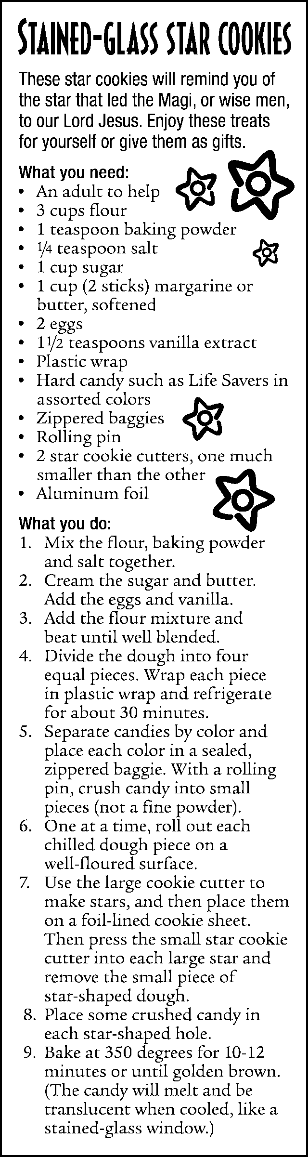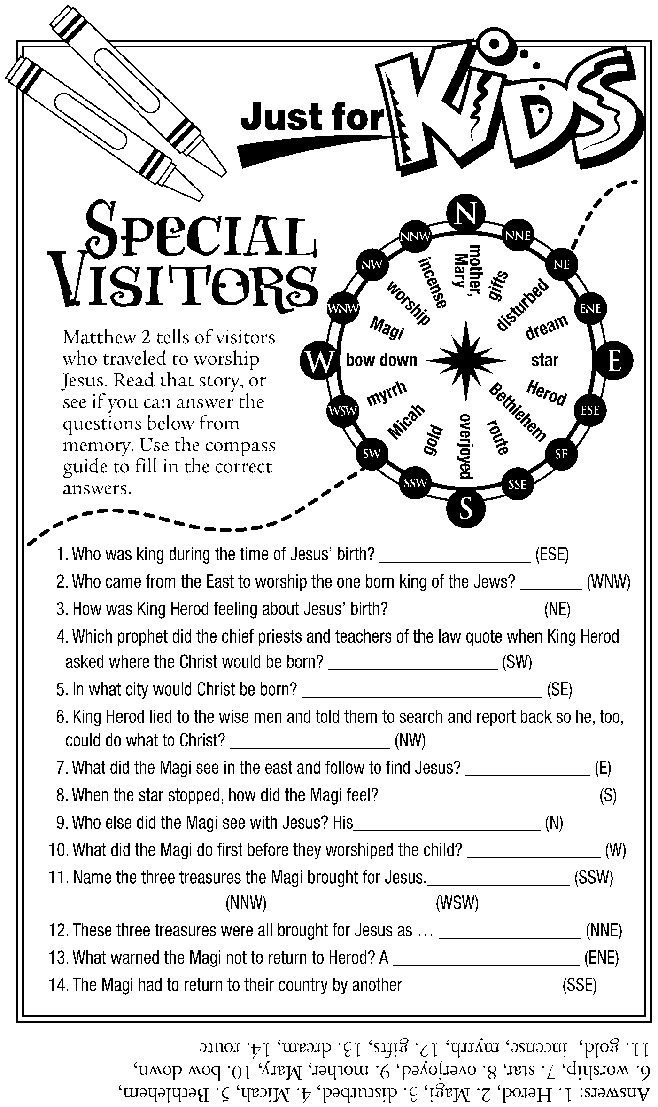

EVERYONE is invited to the “birthday party of the year”!

January 17th following worship

ALL CHURCH BIRTHDAY PARTY

Lunch will be a planned potluck with the main course furnished. There will be
decorations and tables for each month where you will sit with your birth month mates for a FUN time.
Mark the date on your calendar and watch for sign-up sheets for table hosts and potluck selections.

