Joyful Notes

December 2010

“Open Hearts. Open Minds. Open Doors”

LIFE OF OUR CHURCHES…

Astoria and Warrenton United Methodist Churches
Pastor: Rev. Judy Johnson Diaconal Minister: Jane Hill
Administrative assistant: Linda Grznar







Decorating the tree and churches All are welcome to join us.
In Warrenton, we will decorate on Wednesday, December 1 at 1 pm.
In Astoria, we will decorate Saturday, December 4 at 10 am. Come join us.

John Nilsen to join us in Worship December 12
Pianist John Nilsen will be joining us in worship at both churches. His gentle music will offer us a time to reflect and stay anchored in preparing for the gifts of the season: hope, peace, joy and love.

Visioning Conversations with Kate on December 12
Kate Conolly, our Western District assistant to the Bishop (formerly called district superintendent) will be joining us for a focused conversation on where we think we will be in 5 years. In Astoria, the conversation will be after worship. Lunch will be served. In Warrenton, the conversation will be at 3 pm.
All are invited to take part in these conversations about the future of our churches. Questions to consider:
What’s most exciting about your church?
If someone spent a month at your church and did a thorough analysis of your congregation, what is one thing they’d say you need to work on?
What are the main assets and biggest barriers in your ministry setting?
What is your sense of what God is calling your congregation to do in this place?
Pretend you have a crystal ball… What do you see happening in your church two years from now? Five years? How realistic is your vision? What would need to happen between now and then to make this a reality?
Astoria’s Children’s Pageant will be
December 19 during worship at 11 am.
Please join us as we hear the Christmas story through our kids
under the direction of Elizabeth Mannarino.
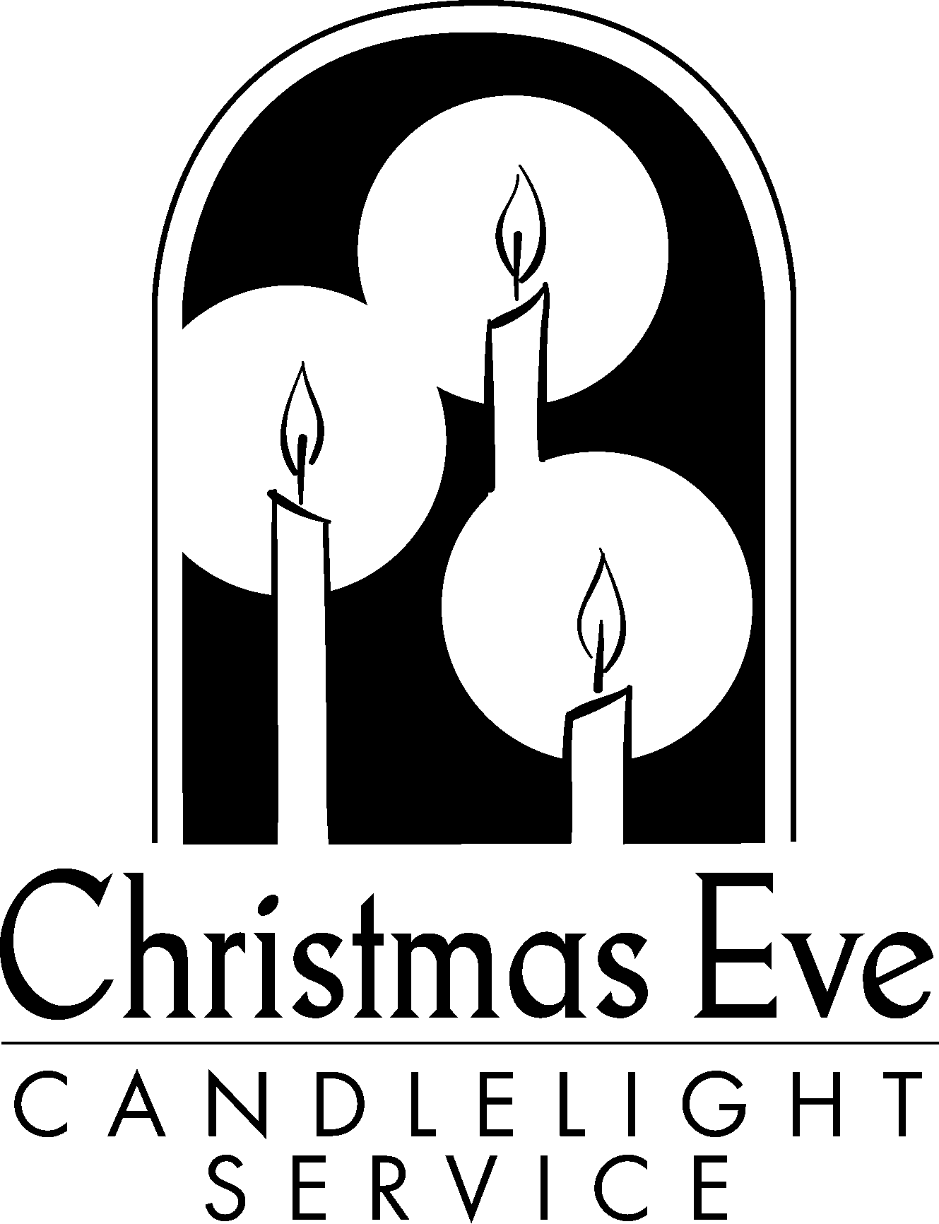

Christmas Eve Services Friday, December 24
Join us as we light candles, hear the story, sings carols
and celebrate the birth of our Savior. Invite a friend.
Warrenton, 5 pm
Astoria, 10 pm

2

The Turkey is stuffed!! Wahoo! Gobble, Gobble!
Through a wonderful show of generosity, Astoria’s Stuff the Turkey campaign exceeded it’s goal of $7500. Thank You! Thank You! If you haven’t yet been able to contribute, your special gift will give us an even bigger cushion to start the new year. You are all REALLY APPRECIATED.

Please Pray for
- All with health concerns and Ginie Tate, Dorothy Lindstrom, John Williams, Don Morden, Gladys Dyer, George and Helen Gunn, Joanne Soderman, Yvonne Comins, Bernice Winn, Nettie Blair, Jim Hill, Alicia Hess, Sue Hicks, Dr. and Mary Kettlekamp, Irene Davis, Rae Estes, Carol Boothe, Trudy Anglim, Sharon Kastl, Laurel Nichols, Bill and Edna Leonard, Charlotte Patching, Jim Swanson, George’s sister Ruth, Diane Curs, Mary Ann Ylipelto, Gladys Dyer’s sister, Tom Dyer, Norman Doney, Sharon Wolf, Maxine Dymond, Bruce Dymond, Pam Jenkins, Scott Kindred, Charlie and Nellie Hansen, Bob Tate, Pat Kujala, Carol Clark, Delores Hodney, Joy, Jeff, Jessica and Joseph, Ginny Bynum, Verna Davis, Elizabeth Mannarino, Jewell Smotherman, Rose Marie Thompson and her brother. All who are ill and their families.
- All who are mourning
- People who find the holidays a very hard time
- People in transitions. People who have lost their jobs, homes, life savings, self-worth
- Our nation’s leaders
- Those affected by natural disasters
- All who are serving our country
- New parents, single parents, all parents and children.
- The hungry, the homeless, those in prison, those living in violence, those with addictions and their families
- Pray for reconciliation and healing in families and between countries.
- Please pray to grow in faith and pray for our churches
- Pray for your neighbors and your enemies

Special People
- A HUGE THANK YOU! to Linda Grznar for her creativity and skills in Astoria’s Stuffing the Turkey,
and also thanks to Harry, Gloria, Mary Frances, Don, Anne, Jane & Judy for their help. Praise the Lord and Glad Tithings for the Spirit that fills us all.
- All who have given to the stuff the turkey campaign in both churches.
- All who took part in the Warrenton holiday lunch and sale. Over $800 was raised for the budget.
- All who took part in the Astoria UMW bazaar. Over $1500 was raised for missions.
- The folks at Blue Scorcher Bakery who helped our kids raise over $300 for Pennies for Peace. They made pretzels that were sold at a high school football game.

Astoria Christmas Offering

The annual Christmas offering will go to local missions (Pioneer House, Rescue Mission) and the Erberle Covenant. Monies above these budgeted amounts will go to World Service.

Special Tax Reminder
IF you are planning on giving money to the church and want to receive credit for your 2010 taxes, PLEASE have your offering into the church by Sunday, December 26 (not the day or two after). This makes it so much easier for the record keepers.
3


Christ monograms
During Advent, many churches display Christmas trees decorated with Christian
symbols called “chrismons.” The name comes from the Latin phrase Christi
Monogramma, which means monogram of Christ. They can be handmade or purchased at Christian supply stores. The symbols, which represent aspects of Jesus’ life and ministry, include stars, angels, keys, doves, boats and various types of crosses.
In Astoria, several years ago, Dorothy Lindstrom counted cross-stitched 150 of the 180 chrismons that decorate our tree. Truly a labor of love. Thank you to all who help remind us of who we celebrate.

Prayer chain update
There have been some changes in the prayer chain in each church. A new list will be printed in January. Please check the lists below. If this isn’t right – if you want to be added or deleted from a list, let the Astoria office know. 503-325-5454 (Email is the quickest and easiest way to keep informed.)

Astoria Phone Chain: Joanne Soderman, Bev Aspmo, Kathy Patterson, Helen Gunn, Diane Grumbling,
Jane Hill, Bill Leonard, Dorothy Lindstrom, Elizabeth Mannarino, Laura Hutson, Violet Olsen,
Charlotte Patching, Marla & Josh McConnell, Pat Williams, Judy Mattson, Bob Hollingsworth
Warrenton Phone Chain: Maxine Dymond, Sharon Wolf, Laurel Nichols, Carol Clark, Gerry Henry,
Bernice Winn, Irene Davis, Rosemarie Thompson, Linda Williams, Ann Maize, Nettie Blair, Gladys
Dyer, Jim Swanson, Anne Stark
Email: Chuck & Molly Albright, Mary Frances Gunn, Jane Hill, Pastor Judy, Greta Robinson, Maryann
Ylipelto, Anne and Don Morden, Carolyn Hammer, Diane Curs, Gloria Jones, Linda Laine, Mary
Lovvold, Pat Williams

PASTOR JUDY’s message
I am truly blown away by the generosity evidenced in the response to the Stuff the Turkey campaign in Astoria. Thank you everybody. You are awesome!!
You know who else is awesome? God. We are entering a season of worldly franticness while the church says wait, watch, prepare – slow down and appreciate the generosity and love of God. God gives us abundant grace, everlasting life and amazing love in the gift of Jesus. Join us in December as we explore the gifts of hope, peace, joy, and love. My prayer for you this season is that you will find many moments of a sense of peace and gratefulness as you go about busy lives. The Upper Room or another seasonal devotion can help you in your discipline of staying grounded in the “reason for the season.” May the breath of God fill your Advent and Christmas.
Christmas blessings, Judy
On another note, I hope you will be able to give serious consideration to the questions Kate brings before us on December 12 (see first page). If possible, each of you might take a moment and actually jot down your concerns and celebrations of our church. (You don’t have to hand them in.) I find the discipline of writing very helpful in keeping me focused on the question. If you can’t come to the meeting, you are welcome to share your thoughts with your lay leader (Don Morden, Anne Stark), Jane Hill or me.
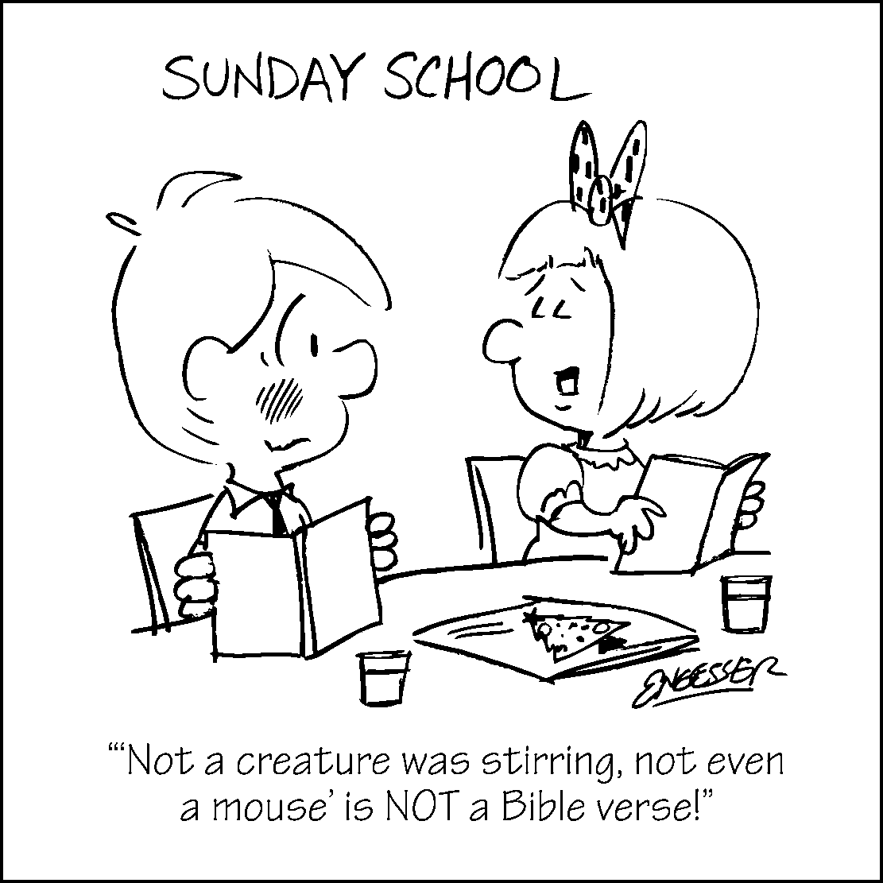
Did you hear about the pastor who was arrested as a money raiser? I have been “honored” with an arrest warrant by the folks at Muscular Dystrophy fund raising. I report to jail at Baked Alaska on Thursday December 16. It is suggested I raise over a $1000 bail. If you are so inclined to donate to this cause, I will appreciate your contribution. Judy

“Not a creature was stirring, not even
a mouse” Is NOT a Bible verse!”
4
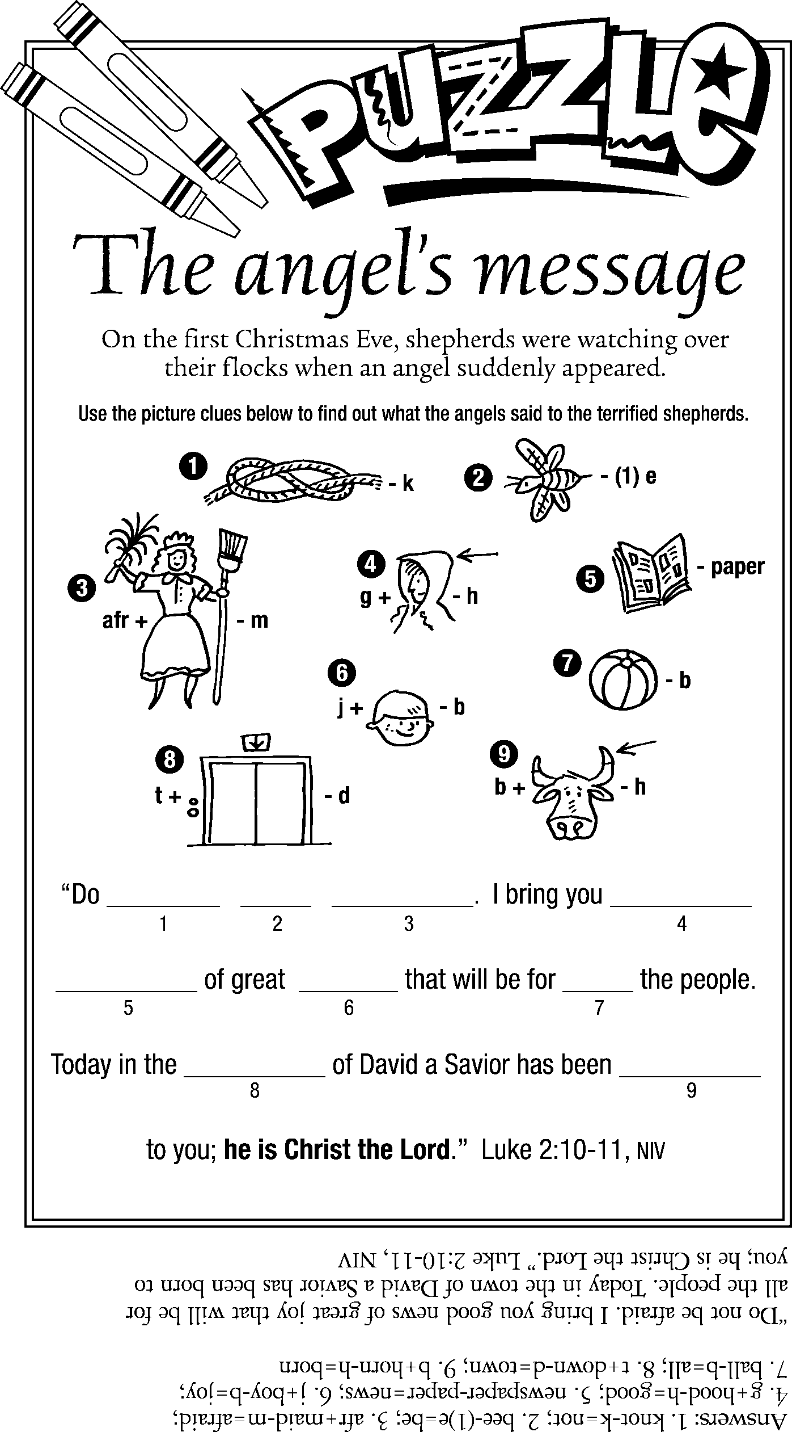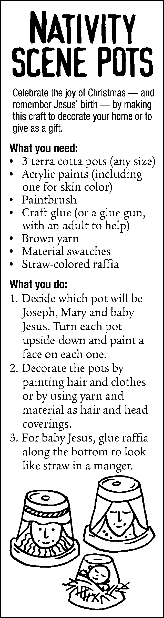

*** “Christmas began in the heart of God. It is complete only when it is in the heart of man.”
—Anonymous
*** “To see his star is good, but to see his face is better.” —Dwight L. Moody
*** “The Son of God became a man to enable men to become sons of God.” —C.S. Lewis

