Joyful Notes

January 2011

“Open Hearts. Open Minds. Open Doors”

LIFE OF OUR CHURCHES…

Astoria and Warrenton United Methodist Churches
Pastor: Rev. Judy Johnson Diaconal Minister: Jane Hill
Administrative assistant: Linda Grznar





Extravagant Generosity, January 8, 2011
An exciting and informative afternoon, 12-4 pm, January 8 at Forest Grove UMC is planned for those who are interested in the future of our churches. A recent publication described five characteristics that healthy, vital churches share. Extravagant Generosity is one. (Radical Hospitality, Passionate Worship, Intentional Faith Development, and Risk-taking Mission and Service are the others.)

We will hear from Rev. Bill Mullette-Bauer from the conference office and other special speakers. I find Bill’s presentations realistic, hopeful and Spirit-filled as he talks about finances and being stewards of all God provides. While part of generosity concerns money, other aspects of generosity include sharing our buildings, time, talents, worship, and information about what we do. We will learn about extravagant generosity and how to enrich or begin the special things only a church can provide.

There will also be workshops for trustees, finance committees, members of SPRC, worship leaders and a whole lot more. See the brochures that are on the bulletin board and tables. I hope we can have lots of people go. We will carpool. Please let the office or pastor Judy know by January 3 if you can attend. Please put this on your calendar. We will need to have eaten lunch before we arrive.

Not feeling so Extravagantly Generous???
Many of us were raised to keep financial issues private. Our parents probably did not share their budgets with us. We learned it was impolite to ask about money issues. And so, we are very uncomfortable about talking about money. Especially in the church. You often hear complaints that the church is always asking for money. We become defensive when someone talks about tithing. I can barely pay my bills now, we say. How can I give 10% of my income to the church?

Statistically, money issues cause more divorce than other matters. We live in guilt and shame about how much debt we have. Worry about bills causes a lot of stress. This worry and stress about money can be a huge detractor from our focus on God, a barrier to our relationship with God. Money becomes a faith issue. Look for a focus on this faith issue beginning the middle of January.

Please note: Meals for Circle of Security start January 6.
There will be a meeting of the Astoria cleaning crew January 23. We need more volunteers.
Call the office if you want to be added or deleted from the prayer chain.

Judy’s corner
At Kate Conolly’s suggestion, we looked into the crystal ball at what we saw for Astoria First UMC in
2-5 years. Some of us had enough courage to name that we saw some people missing, continued financial struggles, and maybe a smaller congregation. And then Chuck said he saw a youth group for the kids we have now. I felt our almost physical shift in outlook – from gloom and doom to yes, by golly, we have a purpose here. We have kids we want to share our faith with. We have people who we want to know about God’s love. We have folks that we can teach and nurture in faith, hope, service, and assurance of God’s transforming grace for all. We have an exciting future.
Please Pray for
- All with health concerns and Jean Curry, Dave Kinman, Dorothy Lindstrom, Gladys Dyer, George and Helen Gunn, their daughter Georgia, Joanne Soderman, Yvonne Comins, Bernice Winn, Nettie Blair, Alicia Hess, Dr. and Mary Kettlekamp, Rae Estes, Carol Boothe, Trudy Anglim, Sharon Kastl, Laurel Nichols, Bill and Edna Leonard, Charlotte Patching, Jim Swanson, George’s sister Ruth, Diane Curs, Mary Ann Ylipelto, Tom Dyer, Norman Doney, Sharon Wolf, Maxine Dymond, Bruce Dymond, Pam Jenkins, Scott Kindred, Charlie and Nellie Hansen, Bob and Ginie Tate, Pat Kujala, Carol Clark, Delores Hodney, Joy, Jeff, Jessica and Joseph, Ginny Bynum, Verna Davis, Elizabeth Mannarino, Jewell Smotherman, Rose Marie Thompson and her brother. All who are ill and their families.
- All who are mourning including the families of Ola Labiske,
- People affected by the Astoria fire.
- People in transitions. People who have lost their jobs, homes, life savings, self-worth
- All who are serving our country
- New parents, single parents, all parents and children.
- The hungry, the homeless, those in prison, those living in violence, those with addictions and their families
- Please pray to grow in faith and pray for our churches
- Pray for your neighbors and your enemies

Special People
- Welcome to Sophia Genoveva Moreria-Bello, born December 8, 2010. How great she was able to be in her very first Christmas pageant as the baby Jesus.
- Congratulations and wahoo to Desiray Parker and Sara Simpson for graduating from Drug Court.
- A big thank you to all who made Astoria’s Stuff the Turkey campaign such a success. $8,835.69 was raised.
- Thank you to the Advent candle lighters: Linda Williams, Irene Davis, Anne Stark, Sharon Wolf, Laura Hutson, Bev Aspmo, Violet Olsen, Sara Simpson, Marla McConnell and family, the Gunn family.
- All who helped make the Christmas Pageant so successful are truly appreciated. Special thanks to Elizabeth Mannarino and the adults who helped her. The kids were awesome.
- Hats off to Bob Gauthier for the countless things he does and will do now that we have found a new leak in an upstairs classroom. (Is a new roof in the future???)
- Thanks to all who lifted, pushed, pulled, got on ladders, fussed with lights and shared time in decorating the trees and churches for Christmas. Volunteers in January will be needed to un-decorate. In Warrenton, Wednesday, January 5, 1 pm. In Astoria, Friday, January 7, 10 am.
- Thank you to all who provided “bail” for my “arrest” as a fundraiser for Muscular Dystrophy. A fun thing is the “Get Out of Jail Card” the Warrenton church also presented.

Brand New
I am the new year. I am an unspoiled page in your book of time.
I am your next chance at the art of living. I am your opportunity to practice what you have learned about life during the last 12 months.
All you sought and didn’t find is hidden in me, waiting for you to search for it but with more determination. All the good you tried for and didn’t achieve is mine to grant when you have fewer conflicting desires.
All you dreamed but didn’t dare do, all you hoped but did not will, all the faith you claimed but did not have — these slumber lightly, waiting to be awakened by the touch of a strong purpose.
I am your opportunity to renew your allegiance to him who said, “See, I am making all things new” (Revelation 21:5, NRSV). —Author unknown

Jane’s Corner
I am so grateful for our commitment to safety and security in our church programs and activities as contained in the Safe Sanctuaries policy. Usually, we think of that policy mostly in relation to our work with children, but, we must expand our perspective to include the elderly. I found this article important and wanted to share it with all of you. Elder Abuse is an ever-increasing issue for our community and for our call to love and justice for all people.
“According to the National Center Elder Abuse, elder abuse refers to any knowing,
intentional, or negligent act by a caregiver or any other person that causes harm
or serious risk of harm to a vulnerable adult.” This includes financial, physical,
emotional, neglect, sexual or abandonment actions.

Who is at risk? Women and the very elderly are most at risk. Abuse affects seniors
Across all socioeconomic groups, culture, and races. In 2003, 2 out of every 3 (65.7%)
Elder abuse victims were women and more than 2 in 5 victims were age 80 or over.

Further detail and information is available through the church office and a copy of the article is posted in the Powell-Turner Room. We are asked to know how to recognize the signs of mistreatment, how to contact the proper authorities, and how to take precautions to help prevent and respond to elder abuse.

As you ponder, pray and practice – consider Psalm 141:8-10, the prayer of all vulnerable people, no matter their age or location. The source for this information is www.aging-umc.org and “Center Sage” issue 20/Fall 2010.

UNITED METHODIST WOMEN NEWS

The PURPOSE statement of UMW is strong and when a unit tries to live into that statement they thrive. The Astoria unit has done well this past year as a community of women whose PURPOSE is:
To know God and to experience freedom as whole persons through Jesus Christ.
To develop a creative, supportive fellowship;
And to expand concepts of mission through participation in the global ministries of the church.

We wish to thank all of our church family for their loving support this past year. We have elected a new slate of officers for 2011, who will be inducted during worship Jan. 9, they are:

President: Anne Morden Spiritual Growth: Carolyn Hammer
Vice President: Sue Hicks Membership, Nurture & Outreach: Mary Lovvold
Secretary: Joanne Soderman Education and Interpretation: Gloria Jones
Treasurer: Violet Olsen Secretary of Program Resources: Pat Williams

Our regular meeting time is 2:00 p.m. the second Wednesday of the month. Won’t you please join us in making 2011 a meaningful year for United Methodist Women. Gloria Jones

Adult Sunday School

The class meets in the library on Sundays at 9:45. The materials we discuss are eclectic and each theme covers about a quarter of the year. New thoughts and insights are a result of our discussions that are lively and challenging. All are welcome and we invite you to make this class part of your Sunday experience in 2011.

• “I am so made that worry and anxiety are sand in the machinery of life. Faith is the oil.”
—E. Stanley Jones
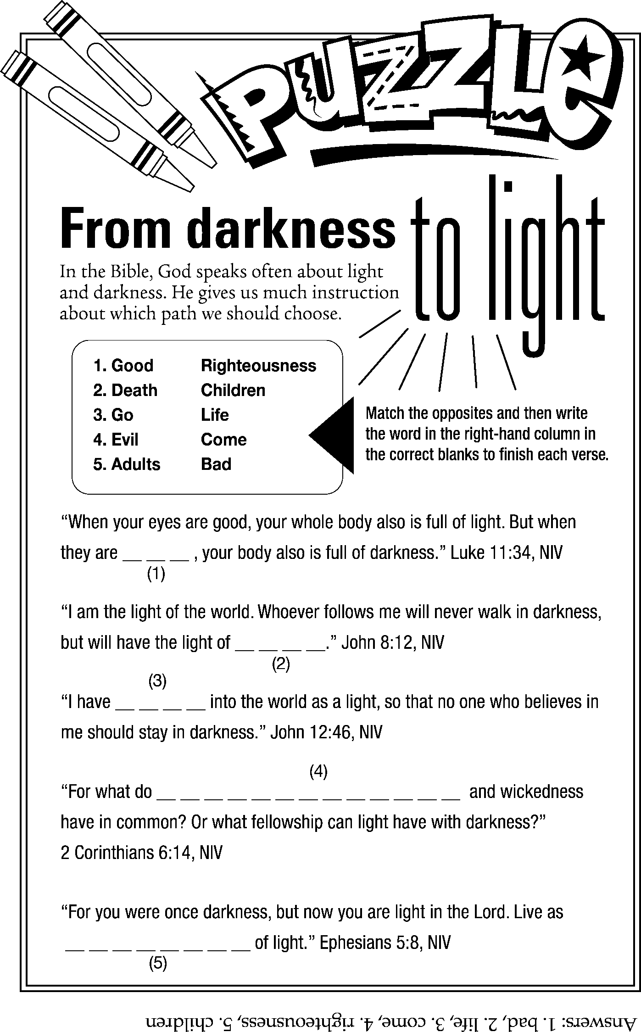

Missing Pronouns

You cannot pray the Lord's Prayer and even once say I.
You cannot pray the Lord's Prayer and even once say My.
Nor can you pray the Lord's Prayer and not pray for one another,
To ask God for “our” daily bread, you must include your brother.
For others are included ... in each and every plea,
From the beginning to the end of it, it does not once say Me.

