Sunday | Monday | Tuesday | Wednesday | Thursday | Friday | Saturday
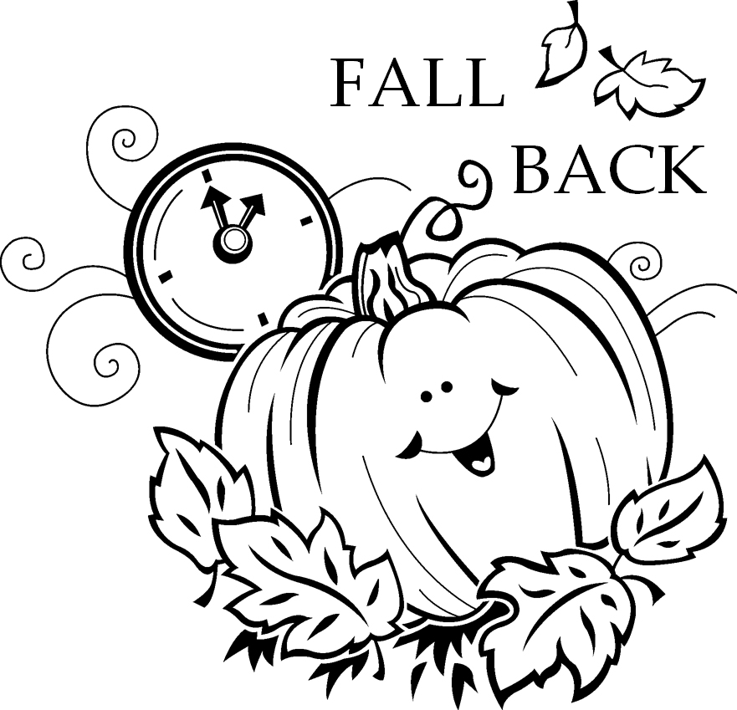  Sunday  Nov. 7th  | 1  8 a.m. UMM @  Andrew & Steve’s  12 AA-W  5:30 pm AA (W)  7:30 pm Gamblers Anonymous-L | 2  12 AA-W  6 pm Women’s AA – L | 3  Noon – Prayer - L  2 Bible Study (W)  6:30 Choir (A)  12 Al-Anon-W  6 pm AA(W)  6:30 Kung Fu - U | 4  6:30 Finance (A)  Noon Circle of Security -W  6 pm AA Men (W) | 5  Noon Prayer & Share (A)  12 AA - W  5:30 pm AA (W) | 6  Warrenton Holiday  Sale  10 am - 2 pm  Lunch 11-1 pm  9 a.m. AA Men – W
7 9 am Worship (W)  9:45 Adult SS (A)  11am Worship and  Children’s SS (A)  Church Council  following worship (A)  2 p.m. Warrenton  Charge Conference  6 pm Al-Anon-L | 8  8 a.m. UMM @  Andrew & Steve’s  12 AA-W  5:30 pm AA (W)  7:30 pm Gamblers Anonymous-L | 9  Noon - UMW  Executive meeting  In Fellowship Hall  12 AA-W  6 pm Women’s AA – L  7pm Sorority (W) | 10  Noon – Prayer - L  2 Bible Study (W)  6:30 Choir (A)  12 Al-Anon-W  6 pm AA (W)  6:30 Kung Fu - U | 11  Noon Circle of Security -W  6 pm AA Men (W) | 12  Noon Prayer & Share (A)  12 AA - W  5:30 pm AA (W) | 13  UMW Holiday  Sale & Lunch  10 am - 2 pm  Lunch 11:30-1:30  Astoria  9 a.m. AA Men – W
14 9 a.m. Worship (W)  9:45 a.m. Adult SS (A)  11 am worship &  Children’s SS (A)  3 Choir Festival @ Nehalem UMC  6 pm Al-Anon-L | 15  8 a.m. UMM@  Andrew & Steve’s  12 AA-W  5:30 pm AA (W)  7:30 pm Gamblers  Anonymous-L | 16  12 AA-W  6 pm Women’s AA – L | 17  Noon – Prayer - L  2 Bible Study (W)  6:30 Choir (A)  12 Al-Anon-W  6 pm AA (W)  6:30 Kung Fu - U | 18  Noon Circle of Security -W  6 pm AA Men (W) | 19  Newsletter  Deadline  Noon Prayer & Share (A)  12 AA - W  5:30 pm AA (W) | 20  9 a.m. AA Men – W  9am-4 pm Quilters (W)
21 9 am Worship (W)  9:45 a.m. Adult SS (A)  11am Worship and  Children’s SS (A)  Stuff the Turkey  6 pm Al-Anon-L | 22  8 a.m. UMM @  Andrew & Steve’s  12 AA-W  5:30 pm AA (W)  7:30 pm Gamblers  Anonymous-L | 23  12 AA-W  6 pm Women’s AA - L  7pm Sorority (W) | 24  Noon – Prayer - L  2 Bible Study (W)  NO Choir (A)  12 Al-Anon - W  6 pm AA (W)  6:30 Kung Fu - U | 25 Thanksgiving  Noon Circle of Security- W  6 pm AA Men (W) | 26 Noon (A)  Prayer & Share  12 AA - W  5:30 pm AA (W) | 27  9 a.m. AA Men -- W
28 9 a.m. Worship (W)  9:45 a.m. Adult SS (A)  11 am Worship and  Children’s SS (A)  1st Sunday of  Advent  - - - SALE 12:30-4 - - -  6 pm Al-Anon-L | 29  8 a.m. UMM @  Andrew & Steve’s  12 AA-W  5:30 pm AA (W)  7:30 pm Gamblers  Anonymous-L | 30  12 AA-W  6 pm Women’s AA - L

November 2010

UMW HOLIDAY BAZAAR set up in Fellowship Hall & Wesley Room

Mary Martha Fellowship
no meetings in November

Family Drug Court GARAGE SALE
Fri-Sat 10-4 Sun 12:30-4

U = Upstairs Classroom
W = Wesley Room L = Library
FH = Fellowship Hall
PT = Powell-Turner Room
(A) = Astoria FUMC
(W) = Warrenton UMC

First United Methodist Church
1076 Franklin Ave
Astoria OR 97103
503-325-5454
Email: office@astoriafumc.org
Website: www.astoriafumc.org

Return Service Requested

November
Birthdays

Charlotte Patching

Steve Patterson

6 Diane Butler

Abby Albright

Chauncey McConnell

Ann Maize

Adriana McConnell

18 Ola Labiski

Audrey Paetow

Brian Larson

Matt Patterson, Sr.

Phillip Gauthier

Mary Kettelkamp

David Maki

24 Bernice Winn

Jim Spain

May God Bless You on Your Birthday

