Joyful Notes

November 2010

“Open Hearts. Open Minds. Open Doors”

LIFE OF OUR CHURCHES…

Astoria and Warrenton United Methodist Churches
Pastor: Rev. Judy Johnson Diaconal Minister: Jane Hill
Administrative assistant: Linda Grznar







Turn clocks back one hour on Saturday, Nov. 6th
or you’ll be early to church.

Warrenton Holiday Sale and Lunch, Saturday, November 6, 10 am – 2 pm
Join us for a sandwich, salad and pie as you purchase baked goods and items for yourself or gift giving. Lunch is from 11 to 1. All are invited to join us at the Warrenton church.


Astoria United Methodist Women Holiday Bazaar

Saturday, Nov. 13, from 10 am – 2 pm
Cookies, craft items and our famous turkey casserole
keep people returning year after year to the Social Hall
of the Astoria church. Lunch is 11:30-1:30. Please join us.

Warrenton Charge Conference, Sunday, November 7 at 2 pm
Rev. Scott Allen will return to the Warrenton church to conduct the Charge Conference at 2 pm. All elected leadership is expected to be there. Others are invited also. Reports, pastor’s salary and membership updates are on the agenda. (Warning: if absent, you may get elected to something.)


Choir Festival at Nehalem UMC on Sunday

November 14 at 3 pm
Choirs from 3 churches join together to make a joyful noise. If you are
interested in going and want to carpool, let the Astoria office know.


Stuff the Turkey, Sunday, November 21
For three Sundays in November, we will be
“growing a turkey” as we give thanks.
Don’t miss the fun!
See the articles in this Newsletter, p 3 and 4

2
Please Pray for
- All with health concerns and Dorothy Lindstrom, John Williams, Don Morden, Gladys Dyer, George and Helen Gunn, Joanne Soderman, Yvonne Comins, Bernice Winn, Nettie Blair, Jim Hill, Alicia Hess, Sue Hicks, Dr. and Mary Kettlekamp, Irene Davis, Rae Estes, Carol Boothe, Trudy Anglim, Sharon Kastl, Laurel Nichols, Bill and Edna Leonard, Charlotte Patching, Jim Swanson, George’s sister Ruth, Diane Curs, Mary Ann Ylipelto, Nettie Blair’s daughter-in-law, Gladys Dyer’s sister, Tom Dyer, Norman Doney, Sharon Wolf, Maxine Dymond, Sylvia Stephens’ daughter Kate, Pam Jenkins, Scott Kindred, Charlie and Nellie Hansen, Bob Tate, Pat Kujala, Carol Clark, Delores Hodney, Joy, Jeff, Jessica and Joseph, Winnie, Ginny Bynum, Verna Davis, Elizabeth Mannarino, Jewell Smotherman, Rose Marie Thompson and her brother, our district superintendent Kate’s mom. All who are ill and their families.
- All who are mourning, and the families of Deana Hatley and Priscilla Gauthier, Jim Hill and family at the death of his brother-in-law Jerry Booker, Jesse and Crystal whose 9 year old son died in an accident
- All with difficult decisions
- People in transitions. People who have lost their jobs, homes, life savings, self-worth
- People who are depressed, feel isolated, thinking about suicide
- Our nation’s leaders
- Those affected by natural disasters
- All who are serving our country
- New parents, single parents, all parents and children.
- The hungry, the homeless, those in prison, those living in violence, those with addictions and their families
- Please pray for peace
- Please pray to grow in faith and pray for our churches
- Pray for your neighbors and your enemies

Special People
- BIG thanks to everyone who helped with the Astoria Garage Sale and the Pennies for Peace cupcake mission project. The Garage Sale brought in over $1600. The Pennies for Peace cupcakes raised $204.94. Special appreciation to Harry Comins, Bob Hollingsworth, Josh McConnell, and Marla McConnell who spent hours and hours both days. Thank you to the many who donated, worked, set up, cleaned up, baked and bought.
- All who attended the charge conference in Astoria. Of biggest note was the approved $2000 reduction in Pastor Judy’s salary. She is now at conference minimum.
- Table angels who set up for the potluck before Astoria’s charge conference. Thank you Mary Frances and Gloria.
- All who led worship while Pastor Judy was on vacation.
- The Astoria UMW for supporting the parenting program, Circle of Security. You can help them by volunteering to provide lunch for about 12 people. See the UMW article page 5. Money also welcome.
- Charlie Hanson for fixing a light (or two) in the Warrenton church.
- The 12-step groups who help both churches with donations of supplies, money and cleaning.

Today as we turn from the rush of daily life,
may we find spiritual rest and renewal.
You alone, God, can give us strength for our journey.

3

GLAD TITHINGS in November

PRAISE THE LORD & STUFF THE TURKEY

Ah, NOVEMBER, our clocks fall back, the days get shorter, the nights longer, the leaves turn colors and go dancing with the wind, time to bring in the harvest.

Beginning November 7th, we bring Glad Tithings to our worship. “Hark”, the angels sing, “We bring blessings of great joy!” Stop … STOP … stand still … STILL … breathe … BREATHE … Let the nervous energy of need and scarcity drop away, let go of poverty and wanting. LISTEN to your heart beating, your blood flowing, your lungs breathing … in and out, in and out. It is good, we are blessed!

For twenty-one days in November we invite you to make a conscious decision to choose gratitude and express your thankfulness with Glad Tithings. We will lift up our many blessings, from spontaneous joy to the promises of our Faith. Rather than asking for God’s blessing, we will be thanking God for this life full of blessings already and STUFF THE TURKEY. On the 7th, we ask you to glad tithe your coin … no bills or checks, thank you (first the seed and then the harvest, first the egg and then the turkey). We will empty our pockets, our purses, our socks and wallets, even look for change in the church pews … change … only change. Change from “not enough” to “abundance, ” from fearful holding to grateful release. Today is a surprise – give from your wonder. During this first week in November, keep a jar by your door and put your grateful change into it for your joyful going out & your safe return.

A penny for your comfort,
A nickel for your smile,
A dime for your laughter,

A quarter for OH, WOW!

It takes 28 days for a turkey egg to hatch. So if we say 1 human day equals 4 turkey days, and the little nest egg of coin we gather on the 7th is a turkey egg, we could have a turkey to stuff in a week. By Sunday the 14th, will our grateful praise hatch so we can stuff the turkey with more glad tithings?
Come and find out!

And what will we do with all of these glad tithings?
In Astoria, read the article “Let’s Talk Turkey” on page 4.
In Warrenton, the project has not been chosen yet.



“Look over there!” said the frightened turkey to his friend the skunk.
“There’s a human with a gun, and he’s getting closer & closer
What are we going to do?”
To which the skunk replied calmly, “Let us spray …”

LOST: One white lace tablecloth. If you have seen it or know where it is, please call Anne Morden.

4

In Astoria, we have a $7500 “loan” from our church fund reserves that must be repaid. We have been borrowing from this fund for the past three years because we have not received enough income to cover our operating costs. On November 21, we will culminate a focused fund drive to raise that money. We need several major gifts and many smaller ones to reach our goal of $7500 in one day. Your gifts are above and beyond your normal giving. This is not our annual pledge drive. That will begin in January.

You have only to read the past Treasurer’s Report to understand how much normal monthly expenditures have exceeded our income. You would also see in these reports how we have budgeted and spent the money we have received as best we could. Over the years we have gone from supporting a full time pastor to a ¾ / ¼ circuit with Warrenton UMC, we have cut administrative staff hours, lowered and monitored heat, electricity and water. We hold garage sales and bake cookies and casseroles. We voted to eliminate a janitorial crew who worked with us since 2004 and took it upon ourselves to clean the sanctuary, kitchen, restrooms, offices, nursery and all. You have worked on the roof, in the basement, painted walls, and patched the ceiling. You have often provided special items needed in the office, for day camp and beyond our walls into the community. We know that pooling our resources allows us to do more as a whole than we can as parts and we regularly support UMCOR disaster relief, Mission Health Kits, Food Bank donations, Meals on Wheels, and you are pretty marvelous cooks, bakers, musicians and artists. We have done well. GOBBLE, GOBBLE, GOBBLE, but we’re still in debt.

We are not alone in this fiscal crisis – the city, the county, state, the nation and many countries are grappling with this as well. Everyone needs money, even the banks. “Public Broadcasting does it, Muscular Dystrophy Association does it, the Library and Maritime Museum, and the Cancer Society do it; many, many non-profit groups ask for money so they can continue doing work that needs to be done.” Everybody seems to be trying to fix this mess by doing the same thing they have always done to get what they want, by crying “poverty” and “need” and “help me”.

Well, we believe it can be different, we believe it is different. We believe there is an abundance, that “In God we trust” means something. So for 21 days in November we ask you to focus on God’s blessings and to bring in your Glad Tithings. We’ll stuff the turkey and give our money a way of becoming the future in which we most want to live.

Life is not a treadmill. Let’s try dancing, and singing and praising the Lord. With your Glad Tithings we choose to pay down, pay off, and eliminate our debt. Let us be free of debt and filled with the blessings of God!

What side of the turkey has the most feathers?

Answer on page __6__

5

United Methodist Women adopt CIRCLE OF SECURITY
Astoria’s United Methodist Women have voted to support the Circle of Security as our local mission. This is a community/court program that identifies people struggling with family issues and provides them with skills needed for healthy relationships. Children & parents participate in a 20-week program examining and evaluating their relationships, exploring their decisions and choices, and developing a road map of action that will lead to a healthy home.

This program is 1 of only 4 pilot programs in the entire state of Oregon. Marla McConnell facilitates the project. It uses videography to analyze patterns of interaction. We’re very excited to be able to help this group achieve its goals and have decided the best way is a hands-on project of providing lunch for their meetings. We are asking the whole church to join us. We need one or two people to provide a simple lunch (i.e. soup, fruit, beverage) each week. You only need to prepare the food and bring it to the church. Marla and her team will take it from there.

We hope you will be as willing and eager to support Circle of Security as we are. We’ll put a sign-up poster in the Powell Turner Room and start gathering the names of those who can help. We will let you know when we need to start the cooking, and will provide you with the number of children and adults we need to feed and some sample menu ideas. We may even be able to arrange pick up for those unable to deliver their meals. If you have any questions, please call Anne Morden or the church office.

“It’s not what we say about our blessings, but how we use them,
that is the true measure of our thanksgiving.” - W.T. Purkiser

PASTOR JUDY’s message
Hope, Peace, Joy, Love
The countdown has already started. The catalogues and ads and Christmas music signal it’s time to buy. And the bigger, the better. They try to fool us into believing that buying, giving and receiving material things will give us hope, peace, joy and love. Buying is such an automatic response that we don’t even question if there is another alternative response. Might a slower, more thoughtful Advent be a response? Note I said Advent, not Christmas. Advent is about taking time, preparing for an expected encounter with God, and preparing to accept and receive God’s gift of grace and love. We do this by keeping our focus, by emptying and opening our selves to God, and by giving in ways that not only affirm others but also helps us say “yes” to God. If you are like many, you say, “Next year it will be different.” Well it is next year and unless we commit now to being intentional about making decisions differently, Christmas will again be disappointing and we will be glad it’s over. Advent begins November 28 this year. Our normal decorations and tree in the church won’t be up until December. We begin slowly, catch our breath, and make a plan to rediscover the hope, peace, joy and love in Christ. One way to do that is to give to a worthy cause in the name of someone rather than buying something they may not need or want. Heifer Project, UMCOR, local missions, the food bank, Pennies for Peace are all places that serve others and need your help. There are many others.
May you have a blessed thanks-giving in November and every day.
Shalom in Christ, Judy

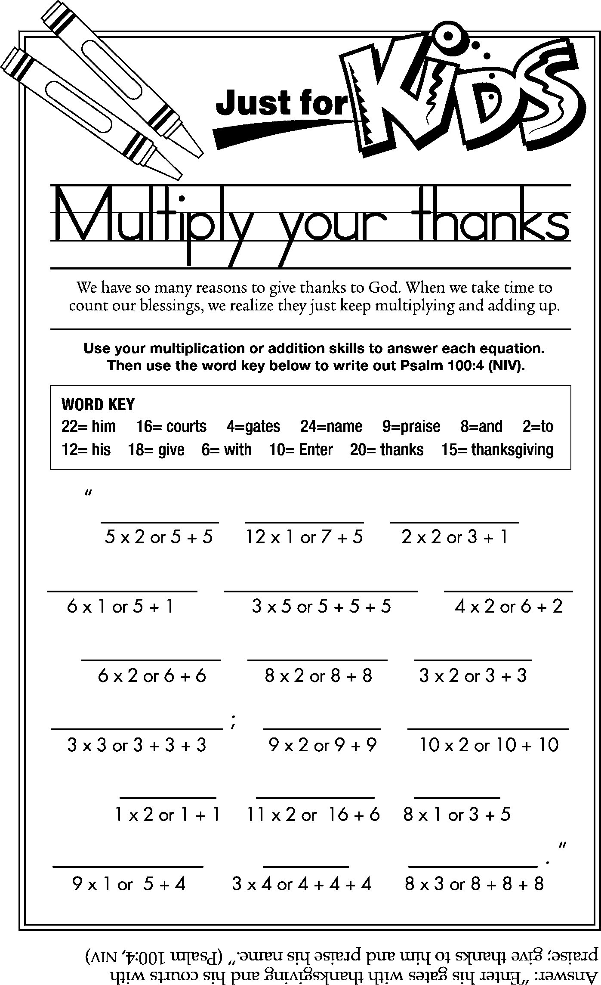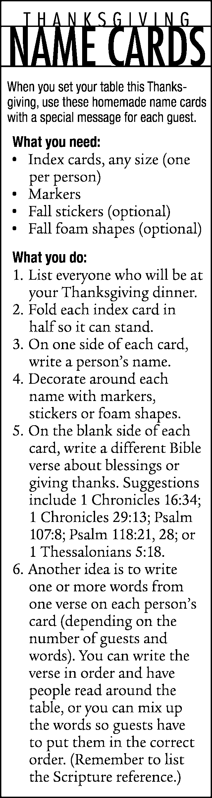
6

“God’s word will work in people’s lives more than any budget.”

THE OUTSIDE!

Answer to question on page 4_

