Joyful Notes

July 2009

“Open Hearts. Open Minds. Open Doors”

LIFE OF OUR CHURCHES…

Astoria and Warrenton United Methodist Churches





Happenings




July 11
7-11 am

Warrenton UMC

Grab your appetite and a friend, and join us July 11 for a pancake breakfast in Warrenton, 7-11 am. Ham, eggs, and pancakes -- $5 for adults. $2 for kids under 10.



Day Camp Sunday July 19

Day camp is August 10-13. Join us for hotdogs, chips, s’more bars and good company after worship July19 as we celebrate this ministry of the church.

Day Camp Theme

Handle with Care

exploring and caring for God’s creation

School of Christian Missions. July 16-19, George Fox University
Every year the United Methodist Women offer an outstanding opportunity for three mini classes in an event called School of Christian Missions. This year the three topics are Food and Faith, Giving Our Hearts Away: Native American Survival, and Sudan. Check the bulletin board in Astoria or talk with Anne Morden, Priscilla Gauthier or Pastor Judy about this event. Registration deadline is now.

Handle with Care – Day Camp Update

The day camp volunteers need your help.
First we request prayer. Pray for the children, the volunteers, safe activities, and that all will experience God’s love and grace. Please pray daily for us and this ministry.
Promote the camp. August 10-13, 9:30 –2. Cost $20. Scholarships are available. Field trips to Fort Clatsop and the trolley.
Invite a child who has finished kindergarten up to 5th grade to participate.
Sponsor a child for $30 or make another financial contribution. The $20 cost above does not cover actual cost of the day camp.
Donate food. Please sign up for the food items on the bulletin board. Anne Morden is in charge of food. She will contact you as to when to bring the food, and how much.
- Cookies, fruit, cup cakes, deviled eggs, other items as posted
Donate time.
- Help prepare snacks and lunches for 40 people. See Anne Morden.
- Be a “shepherd.” These are adults/older youth who oversee a small group of children as they go station to station. We would like 2 adults for each group.
- Be the craft station leader. We know what the crafts are. We just need a person to give instructions to each small group.
- Take pictures
- Please note, if you are working directly with children there is a mandatory training on Wednesday, August 5 at 5:30 pm. A background check form will need to be signed. Pizza will be served. See Pastor Judy if you cannot come.
Donate materials. See Pastor Judy. Please, do not bring them to the church until August.
Note from Judy: If everybody contributes, I will have way too much. So only share a little of your garbage.
- Clean gallon jugs with lids
- Clean, small unusual garbage that you would recycle that can be used for 3-D art – strange shape, color, material
- Glossy colorful magazine pages
- Seeds
- Clean garbage – both recyclable and non-recyclable. No food or liquids.

OPEN DOOR Request
We are a generous congregation. Can you take on one more mission need? When you shop would you be willing to buy extra detergent, dish soap, toothpaste, toilet paper, etc., to share?

Government decreases in the amount allotted for rent has put some of our neighbors in a financial bind and they are desperately seeking help. The director of Open Door has requested our help in supplying basic hygiene, both personal and household, items for their clients.

Any of these items placed in the Open Door bin in the Powell-Turner Room will go directly to Open Door to be distributed to the most needy by the director there.

Thank you for any help you can provide. It will be greatly appreciated.

Please Pray for
- Gloria Jones and the other Volunteers in Mission team members as they represent us in Kenya June 25 to July 14
- The over 100 people locally who will be homeless when their housing subsidies are stopped
- The human service agencies who are dealing with increased need for help with shrinking resources
- Those with health concerns: David Maki, Lori Kindred, Irene Davis, MaryAnn Ylipelto, Russell Maize, Norman Downy, Sharon Wolf, Ginnie Tate’s brother John, Sylvia Stephens’ daughter Kate, Laurel Nichols and her son Jerry, Joy, George Gunn, Pam Jenkins, Scott Kindred, Charlie and Nellie Hansen, Maxine Dymond, Bob Tate, Carol Boothe, Pat Kujala, Carol Clark, Waletta Kempt, Delores Hodney, Ginny Bynum, Al and Verna Davis, Priscilla and Bob Gauthier, Elizabeth Mannarino, her 5 y/o grandson Leo, Jewell Smotherman, Rose Marie Thompson and her brother, our district superintendent Kate’s mom. All who are ill.
- All who are mourning, and in particular: the family of Mark Davis who died – John and Irene, Jennifer and the rest of the family; Phil Bales and family at the death of his dad, Mary Lovvold’s brother Don and family at the death of his son Patrick
- The churches, clergy and families that are involved in change of appointments
- Those getting married
- All those who are moving or in some other kind of transition
- Pray that peace, patience, kindness, and trust in God will replace our fears and will continue to empower us to help people in need in practical ways.
- Pray for the people who have lost their jobs, homes, life savings.
- Children, parents and those who care for them
- Our nation’s leaders
- All the men and women serving in Afghanistan and the Middle East.
- The hungry, the homeless, those in prison, those living in violence.
- Day Camp children and volunteers who will be participating in camp August 10-13.

Special People
- Priscilla Gauthier and Violet Olsen for the new-to-us coffee pots at the Astoria church
- Special thanks to Jeff Smith for all the help he is providing the Warrenton church – lawn mowing and various chores.
- Good by and blessings to Rainey, Mykala and Garrett as they move to the east coast
- Welcome to John and Agnes Waisanen who have become members of the Astoria church after a move from Crescent City to Astor House. They would appreciate getting to know some of our church family. They currently are not able to attend church but wanted to be connected to the local church. Contact Pastor Judy to get more information.
- Those who led worship services June 14 while Pastor Judy, Jane Hill, Anne Stark and Mary Frances Gunn were at Annual Conference. In Warrenton Nettie Blair and Gladys Dyer led worship. In Astoria Don Morden, Mary Ann Ylipelto and Diane Curs led worship. Thank you!
- The many generous people who are financially supporting our churches. Thank you, thank you!!
- Bob Gauthier, Mary Frances Gunn, Bob Hollingsworth, Sue Hicks and grandchildren Maddison, Taylor, and Ethan Hicks, Molly, Chuck, Abby, Claire, and Daniel Albright, Allison Neussl and Brian Larson-- for spiffing up the parking lot and church grounds in Astoria. Good job!!
- The many who contributed to the Change Hunger Fast offerings taken to Annual Conference.
Warrenton contributed $193.40; Astoria $234.55. The total received, over $11,600, will be used to fund hunger projects in Idaho and Oregon.

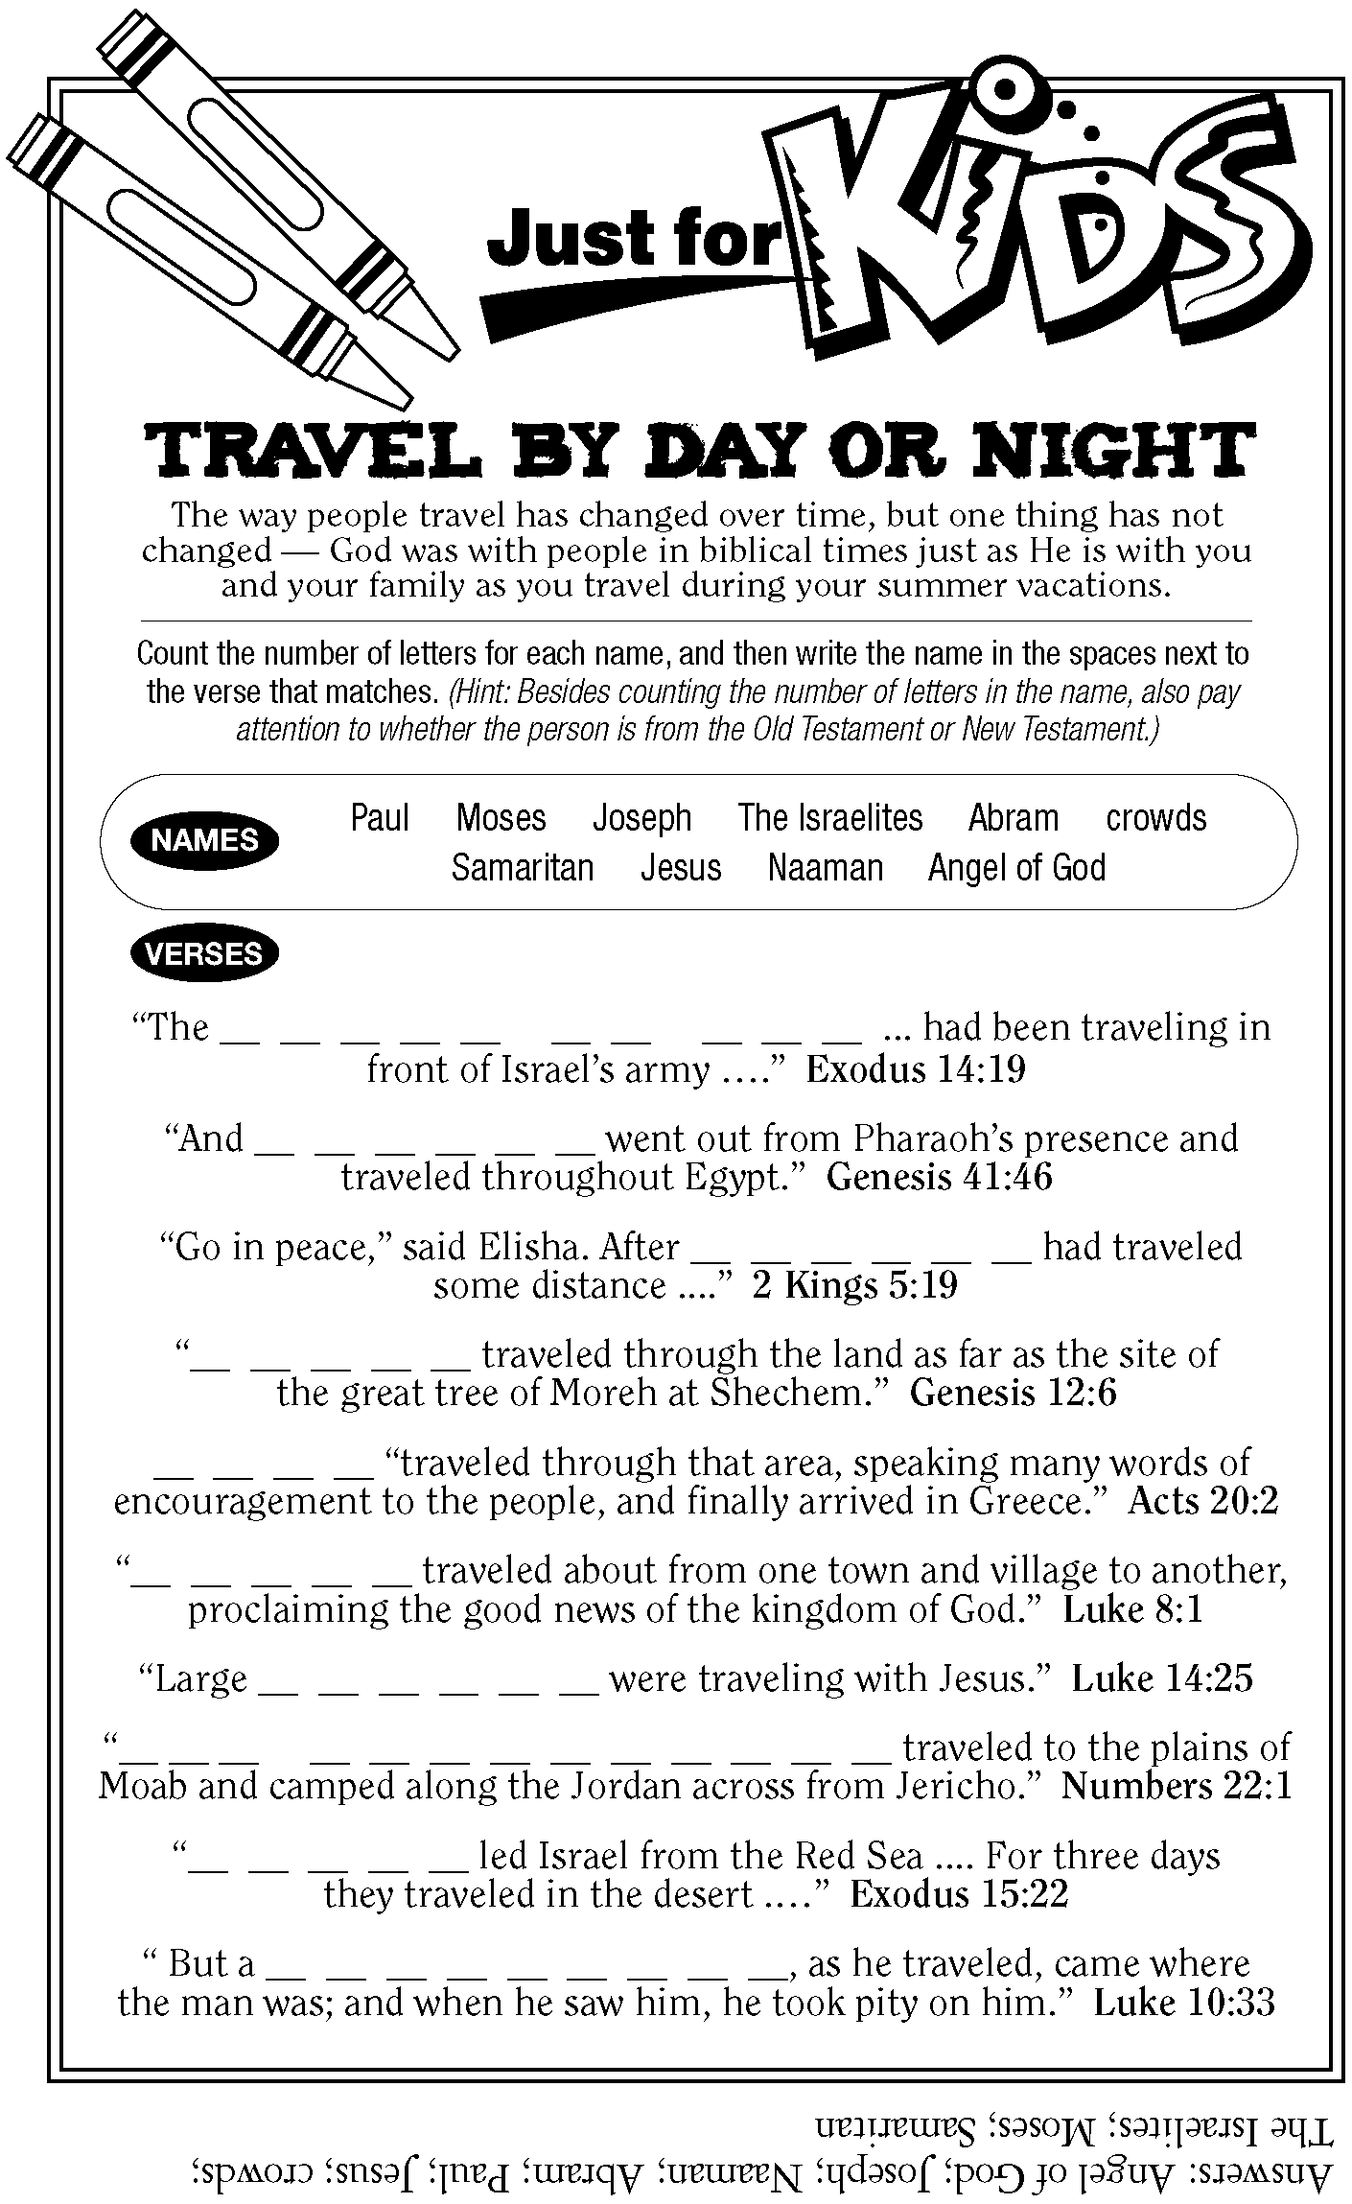

Did you know?
Did you know that the pastor is considered self employed (even though you pay the salary)? That means she/he pays all social security and taxes. Pastor Judy says she tries to save at least a quarter of her pay every month for taxes and social security.

