Joyful Notes

July 2010

“Open Hearts. Open Minds. Open Doors”

LIFE OF OUR CHURCHES…

Astoria and Warrenton United Methodist Churches
Pastor: Rev. Judy Johnson Diaconal Minister: Jane Hill
Administrative assistant: Linda Grznar







Fourth of July Potluck
Carolyn Hammer has invited us to watch the fireworks from her yard.
Bring a blanket if it is cold. A potluck supper will begin around 7 pm.
Carolyn will provide hotdogs and hamburgers.
Please RSVP if you will be coming. 503-325-6172

Pennies for Peace Cupcakes July 11

Join us for another great batch of cupcakes after worship
In Astoria on July 11. Your donations go to our youth who
continue to raise money for the second year of Three Cups
of Tea project that pays the salaries of your girls in Afghanistan. You are in Mission because of your generosity.

Day Camp News
It’s not too early to begin inviting the kids in your neighborhood or family go come to day camp. Pick up a brochure and have it ready to give to kids who have completed kindergarten through 5th grade. The dates are August 9-12, 9:30 –2 pm and lunch is included. We will explore stories about Jesus. The fee for the camper is $20 and scholarships are available. Because the camp costs more than what we are charging the children, you are invited to sponsor a child for $30, but any donation is appreciated. Also needed are the kids, your prayers, and 24 clean Spam-like cans. The cans need to be wide enough and not too tall for gifts we are making for the residents of Astor House when we visit them. We also need more shepherds and other helpers.

Your generosity at work in the world

All people are ministers – a person who cares about people and their
needs in the name of Jesus. I am grateful for all the ministers of the
Warrenton and Astoria United Methodist Churches who are in mission.
You donated 69 health kits I response to the disasters in Haiti and
elsewhere. For the Change Hunger Fast offering sent to Annual
Conference, Warrenton gave $107.53 and Astoria gave $275.44.
(Added to the offerings from other churches and the special offering during conference, the Bishop’s initiative received over $12,000.)
Those wo donated and bought at our UMW one-day sale June 12, allowed $897.25 to be sent to more mission fields. WOW!! Thank you all for your caring and generosity.

Please Pray for
- All with health concerns and Yvonne Comins, Dean Hatley, Bernice Winn, Nettie Blair, Jim Hill, Alecia Hill, Marilyn Hollingsworth, Bill Kopke, Roger Platt, Dr. and Mary Kettlecamp, Irene Davis, Linda Williams, Rae Estes, Carol Boothe, Trudy Anglim, Ginger Ponton, Dorothy Lindstrom, Laurel Nichols, Bev Cox, Bill and Edna Leonard, Charlotte Patching, Jim Swanson, Helen Gunn, Diane Curs, Mary Ann Ylipelto, Nettie Blair’s daughter-in-law, Gladys Dyer’s sister, Tom Dyer, Norman Doney, Sharon Wolf, Maxine Dymond, Sylvia Stephens’ daughter Kate, George Gunn, Pam Jenkins, Scott Kindred, Charlie and Nellie Hansen, Bob Tate, Pat Kujala, Carol Clark, Delores Hodney, Joy, Jeff, Winnie, Ginny Bynum, Verna Davis, Bob and Priscilla Gauthier, Elizabeth Mannarino, Jewell Smotherman, Rose Marie Thompson and her brother, our district superintendent Kate’s mom. All who are ill and their families.
- All who are mourning, including Bob Maxfield and family at eh death of Valerie.
- Day Camp – August 9-12. Please pray for the children and the volunteers
- Churches in transition as pastors change. Our Annual Conference as it reorganizes.
- People in transitions. People who have lost their jobs, homes, life savings, self-worth
- People who are depressed, feel isolated, thinking about suicide
- Our nation’s leaders
- All the men and women serving in Afghanistan, Iraq and the Middle East including Kelly, Rose Marie’s grandson
- New parents, single parents, all parents and children. Pray for Marla McConnell as she works with the “Circle of Security” groups meeting in the Astoria church.
- The hungry, the homeless, those in prison, those living in violence, those with addictions and their families
- Please pray for peace
- Please pray to grow in faith and pray for our churches
- Pray for your neighbors and your enemies
- Those affected by the oil spill



E-mail beauty tips

For attractive lips, speak words of kindness.
- For lovely eyes, seek out the good in people.
- For a slim figure, share your food with the hungry.
- For poise, walk with the knowledge that you never walk alone.
- People, even more than things, have to be restored, renewed, revived,
- reclaimed, and redeemed; never throw out anyone.
- Remember, if you ever need a helping hand, you will find one at the end
of each of your arms.
- As your grow older, you will discover that your you have tow hands;
one for helping yourself, and the other for helping others.

Special People
- Michael Cain who graduated from Warrenton High School. Congratulations! God be with you.
- Those who have contributed to our Change Hunger Fast collection and who give food to the food bank. Cold cereals, protein and canned fruit are always welcome.
- Nettie Blair and all the faith filled people who participated in worship in Warrenton when Anne Stark and Pastor Judy were at annual conference.
- Diane Curs and all the faith filled people who participated in worship in Warrenton when Mary Frances Gunn and Pastor Judy were at annual conference.
- All who participated in the mission fund raising event for UMW. You ladies (and men) are awesome. Special Recognition to Harriet Hugo, a friend of Bev Aspmo’s and to those whose name I am forgetting, for all your giving of time and energy.
- Helping Hands. This is a group of women and men in the Astoria church who set up funeral receptions and spend hours in the church with before and after activities. You are truly a blessing to families in grief.
- All who helped with food after Camp Sunday.
- Everyone who attended the last Social Principles conversation about sustainable agriculture.
- Mary Frances Gunn for being the only person besides pastor Judy to help with the Outdoor Work Party June 19.
- Jane Hill for preaching on Father’s Day: Are you listening for the voice of God?

Pastor Judy’s ramblings
Annual Conference is always a joy, hard work and challenging physically. You will hear more about annual conference in July.
I do however want to share the highlights for me of the ordination sermon by Bishop Dave Brauer-Rieke of the Oregon Synod, Evangelical Lutheran Church in America. We had been hearing all conference about the challenge of change and our importance in sharing the Gospel in a world that is rapidly changing. The Bishop reflected on our diminishing membership in many, many churches. It is not because we have done anything wrong in how we worship or do church. It is because the world is looking for something different. They are looking for words and actions that engage them and provide hope and life.
IN conversations in both Astoria and Warrenton we will continue to seek with prayer how God is calling us to be agents of hope and life to those outside our walls. You will be haring about ways to volunteer in new hunger ministries, new worship opportunities and yet-to-be-revealed unknowns that God will place upon people’s hearts.
On a recent conversation in Astoria, George Gunn shared this thought: Look toward doing those things that God is blessing rather than asking God to bless what we are doing.

A Stewardship Prayer by John Wesley
Oh Lord Jesus…I give you all my worldly goods. Help me to prize them and use them only for you. May I faithfully give back to you what you have entrusted to me, by giving to the poor…especially what I own beyond necessities. Grace me with contentment to part with material possessions, whenever you, my Lord, ask me to give them up. Amen.

The discipline of giving is a response of faithfulness to God’s call and claim on our lives. We are free to give because we trust God to provide. Than you and the members of your congregations for your faithfulness in giving. In these times of economic uncertainty, this is important to remember.
Grace and Peace, Bill Mullette-Bauer, Director of Stewardship and Finance

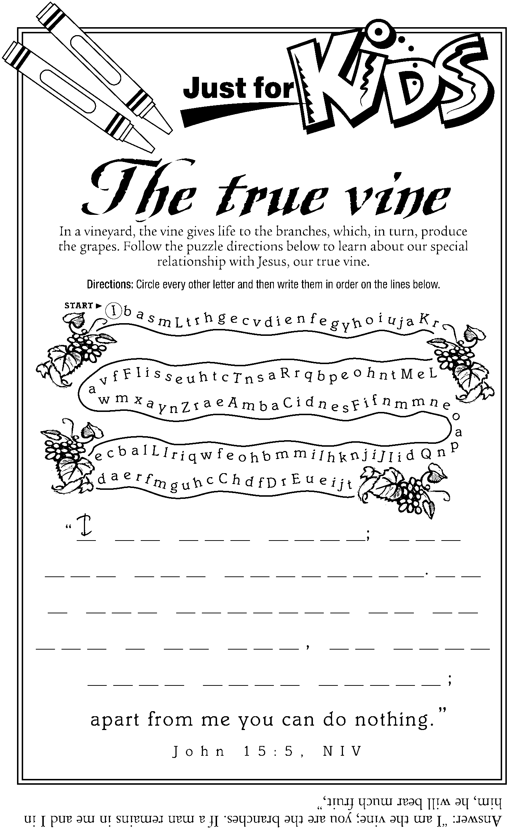

Choose the Better Half
An elderly clergyman chugging slowly along on a sidewalk was hailed by a middle-aged workman as they neared each other.
“Hi, Jerry,” said the workman cheerily. “How are you?”
The old pastor replied, “Oh, I’m about 50/50.”
“Well,” replied the worker, “take the better half and forget the other half.”

