Joyful Notes

June 2010

“Open Hearts. Open Minds. Open Doors”

LIFE OF OUR CHURCHES…

Astoria and Warrenton United Methodist Churches
Pastor: Rev. Judy Johnson Diaconal Minister: Jane Hill
Administrative assistant: Linda Grznar






Camp Sunday, June 6 – hotdogs and “smores”
Come, celebrate the ministry of our Day Camp and join us for lunch. Learn about our theme and our plans. Please plan to stay after lunch for our 2nd opportunity to look at our Social Principles. (See next article.)
There is a Day Camp meeting, Wednesday June 2 at 6:30 pm. All helpers are invited to attend.


2nd Social Principles Study: Sustainable Agriculture, June 6, Astoria
Matt Stanley will be our guest speaker. After we have eaten lunch (see above) we will gather to look at what our the UMC says about sustainable agriculture and new understandings of using our resources.

Annual Conference June 10-13, Salem
Please pray for Annual Conference proceedings, the people attending and the presence of the Holy Spirit. Pastor Judy, Mary Frances, Jane Hill and Anne Stark will be attending this year.
Special opportunity: Leadership Institute, Friday, June 11, 8:15 am See article next page .

Sale: Bedding, Books, Baked & Beyond, June 12, 10-3 pm, Astoria
Help support the United Methodist Women as they raise funds for mission. See article next page.


Special concert June 27, 11:30 am, Astoria
The Astoria Music Festival is giving a concert at 11:30 am, June 27 in the Astoria church as a thank you for using our space for rehearsals. Croissants will be served after the concert.
We will move worship to 10 am that day only.

Astoria Worship Time Changed to 10 am, June 27 only
Because of the concert, we will gather an hour earlier to worship on June 27. We’ll have coffee for the in-between time as well as refreshments after.


Bedding, Books, Baked & Beyond
June 12, 10-3 pm, Astoria
The “Beyond” refers to plants, small household goods and other usable items. (We will not be accepting clothing or shoes.) Lat year we sold out of baked goods, so if you are able and willing, get out those bowls and spatulas. A sign up sheet is on the Powell-Turner bulletin board – please add your name to this baking extravaganza. Your donations of books, bedding, baked goods and starter plants are appreciated.


Outdoor Work Party, Saturday, June 19, 10-12, Astoria
Bring your gloves, clippers, weed diggers, etc to make our yard look
great for the concert June 27.


Ideas and Action Meeting after worship, June 20, Astoria
Please join us after worship June 20 as we begin to talk about what ideas and action
we need to take to move into being the best church we can be in the future. Pray that we will be open to the guidance from the Holy Spirit to discern what ministries God is calling us to do. Bring finger food to share.

ANNUAL CONFERENCE
Some of you have asked what Annual Conference is. The District Newsletter had an excellent description of this annual event and we present it here for you as well. Annual Conference is
- A level of church organization that brings together the United Methodist congregations in a defined geographic area, is overseen by a bishop, has employed staff, and administers the goals and budget set forth by the Annual Conference members in their annual session. The offices of the Oregon-Idaho Annual Conference has a staff of ten people, plus five district superintendents and district administrative assistants with offices in Portland, Salem, Eugene, Bend, and Boise, Idaho.
Each district is comprised of approximately 40 congregations.
- It is the annual meeting of the clergy and lay membership elected from the congregations, empowered to legislate for the congregations and interact with the wider church.
- Besides the legislative sessions, participants have opportunities to take part in Laity Workshops, Worship Services, Ministry Marketplace, Health Screening, conversations and meals.
- Of special note this year is The Leadership Institute at Annual Conference (LI@AC) that is being offered Friday, June 11,starting at 8:15 am. Cost is $25 and there is scholarship help. You can carpool. See Pastor Judy. (I would love to see a bunch of Astoria/Warrenton church folk attend!) This is a wonderful opportunity to hear Rev. Adam Hamilton, pastor of the Church of the Resurrection in Kansas.
Church of the Resurrection had 4 members when Adam Hamilton founded it in 1990 (now it has over 12,000! ) PBS's Religion and Ethics Newsweekly recently identified Adam Hamilton as one of the top "10 People to Watch." He has authored 7 books, including Leading Beyond the Walls (recommended for participants of the Leadership Institute). United Methodists from around the country attend his weeklong Leadership Institutes.
What does your congregation need to become healthy and vital? The LI@AC will allow you to strategize at least 6 concrete steps to take. Bringing just 5 leaders from your congregation to the LI@AC will make a difference for your church's future.
- Please check the following web sites for more information on our OR-ID Annual Conference. It will be happening in Salem on June 10-13. office@westerndistrictumc.org www.umoi.net

UMW NEWS
June 21 is the registration deadline for School of Christian Mission in Newberg. The class offerings are: For the Love of God, John’s Letters, Mission in the Age of Global Christianity and The Beauty and Courage of Sudan. The dates are July 8-11 and Gloria would like you to join us for part or all of the weekend. She assures us it will be enriching and potentially life altering.

From our bookshelf:
“The Other Game” written by Phil Dahl-Bredine and Stephen Hicken. Both men worked at least 7 years with indigenous villages in rural Mexico. The game is how we live our lives, produce our food and sustain our land. Bigger and more modern is not always better. They reference a 2005 report, Ecological Footprint of Nations, “we would need 1.39 earth to insure that future generations are at least as well off as we are now.” Currently we (the US) are playing a game of “personal and collective consumption.” Resources of the earth are being used up at an alarming rate. “The current economic system produces serious basic scarcities…we concentrate wealth in the hands of the few”. The authors propose we change the game and make moves that will support the earth and sustain all peoples. They offer sources for unbiased information and more sources for learning.

Day Camp is planned for August 9-12 at Shively Park. Watch for registration information. It is not too late to volunteer to help with Day Camp. We especially need “shepherds.” These are the folks assigned to accompany a small group of children from activity to activity. You help, encourage and pray with your special group of kids. We will again be offering opportunities to sponsor children (so we can keep the cost down) and opportunities to donate for food and crafts.

Special People
- Colleen Gunn graduating from high school. Congratulations Colleen! God be with you.
- Josh McConnell graduating from 8th grade and recipient of a special recognition by the Youth Commission for his work with Pennies for Peace. Way cool, Josh!
- Bob Gauthier for fixing an office stool, installing an outside railing to the basement, & grass edging.
- Bob Hollingsworth for fixing the downstairs toilet. We “used” 10,000 gallons of water more than normal because of that leak. Please, be sure faucets and toilets are not running or notify the office.
- The choir who so generously share their love of God through music: Bill Leonard, George Gunn, Don Morden, Chuck Albright, Denis Soderman, Jane Hill, Laura Hutson, Anne Morden, Dorothy Lindstrom, Helen Gunn, Pastor Judy, Mary Frances Gunn, Diane Curs.
- Barb and Bill Barrons for giving to the Pennies for Peace project. Thank you.
- A thank you to all who support our kids. We had a guest one Sunday who gave $150. See what happens when we share our faith in ways that reach out.
- Those who support our churches in so many ways.
- Mindy Stokes and her ministry of caring for her students.
- Kenny Adams who makes coffee every Sunday in Warrenton
- Those who have contributed to our Change Hunger Fast collection and who give food to the food bank. Cold cereals, protein and fruit are always welcome.

Please Pray for
- All with health concerns and Bernice Winn, Nettie Blair, Jim Hill, Marilyn Hollingsworth, Bill Kopke, Roger Platt, Dr. and Mary Kettlecamp, Irene Davis, Linda Williams, Rae Estes, Carol Boothe, Trudy Anglim, Ginger Ponton, Dorothy Lindstrom, Laurel Nichols, Bev Cox, Bill and Edna Leonard, Charlotte Patching, Jim Swanson, Helen Gunn, Diane Curs, Mary Ann Ylipelto, Nettie Blair’s daughter-in-law, Gladys Dyer’s sister, Tom Dyer, Norman Doney, Sharon Wolf, Maxine Dymond, Sylvia Stephens’ daughter Kate, George Gunn, Pam Jenkins, Scott Kindred, Charlie and Nellie Hansen, Bob Tate, Pat Kujala, Carol Clark, Delores Hodney, Joy, Jeff, Winnie, Ginny Bynum, Verna Davis, Priscilla Gauthier, Elizabeth Mannarino, Jewell Smotherman, Rose Marie Thompson and her brother, our district superintendent Kate’s mom. All who are ill and their families,
- All who are mourning
- Ola Labiske who has moved to a foster home in Warrenton. Please call the office for her address.
- Day Camp – August 9-12. Please pray for the children and the volunteers
- Churches in transition as pastors change. Our Annual Conference as it reorganizes.
- People in transitions. People who have lost their jobs, homes, life savings, self-worth
- People who are depressed, feel isolated, thinking about suicide
- Our nation’s leaders
- All the men and women serving in Afghanistan, Iraq and the Middle East including Kelly, Rose Marie’s grandson
- New parents, single parents, all parents and children. Pray for Marla McConnell as she works with the “Circle of Security” groups meeting in the Astoria church.
- The hungry, the homeless, those in prison, those living in violence, those with addictions and their families
- Please pray for peace
- Please pray to grow in faith and pray for our churches
- Pray for your neighbors and your enemies
- Those affected by the oil spill

A prayer when challenged
God of wisdom and love, help me and all others who are struggling with difficult circumstances find direction and strength to face our challenges. Give us the assurance that underneath us are your everlasting arms, which will sustain us through everything we face day and night. In Jesus’ name. Amen.
Do you need a Christian tune-up?
If so, here are five tune-up specials for you:
1. Adjust your lights so others may see your good works.
2. Set your timing so as to be at the meeting on time.
3. Adjust the brakes on your tongue.
4. Align your direction so that you may stay on the straight and narrow.
5. Anti-freeze your heart and be fervent in spirit. Above all things, love the Lord your God with all your heart and soul and mind.

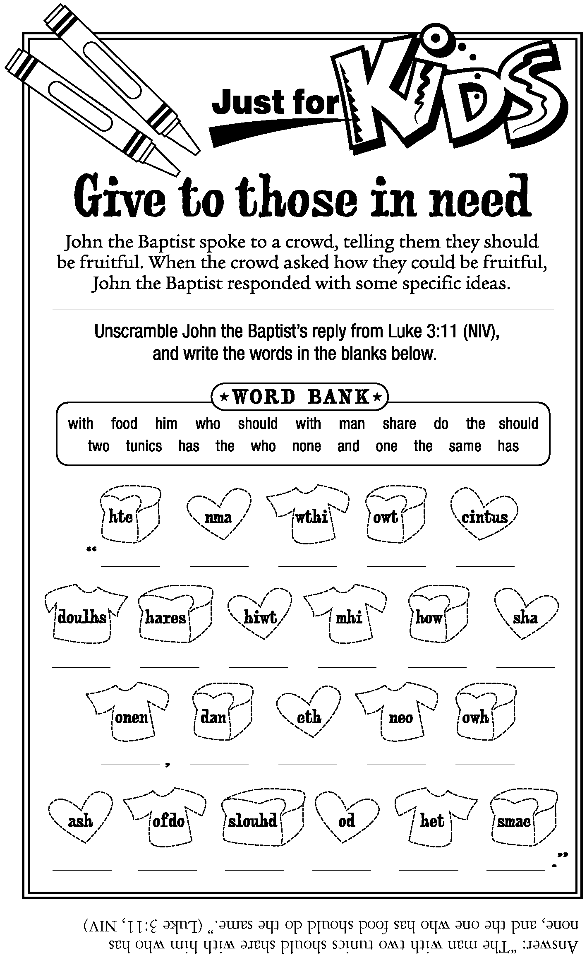

About the Trinity
We call it, in theological terms, the doctrine of the Trinity. But rather than believing in three gods, Christians believe in one God who is manifested in three forms: God the Creator, the Incarnate God (Jesus) and God’s (Holy) Spirit.
Theologian Henry Van Dusen thought of the Trinity in these terms: In God the Father, we see the ultimacy of God; in God the Son, we see the character of God; and in God the Holy Spirit, we sense the intimacy of God.

The grace of God
A man was met at the gates of heaven by St. Peter, who said, “It will take 1,000 points for you to be admitted. The way you lived your life will determine your points.”
The man said, “Unless I was sick, I attended worship every Sunday and sang in the choir.”
“That’s 50 points,” said St. Peter. “What else?”
“I gave liberally to the church,” the man said.
“Twenty-five points,” replied St. Peter. “Anything else?”
Realizing he had only 75 points, the man began to get desperate. “I taught Sunday school for several years.”
“That’s great work for God, but it’s worth only 25 points,” noted St. Peter.
The man became frantic. “You know,” he said, “at this rate the only way I’ll get into heaven is by the grace of God!”
Peter smiled as he said, “That’s worth 900 points! Come on in!”

Ideas and Action – Judy’s ponderings
On June 20, after the Astoria worship service, we will be discussing ideas and actions that we can take as we boldly look into the unknown of how God is going to use us for future ministry. We believe that God has been with us in the good and challenging moments in the history of our churches. Can we trust that God will be with us into the future? One thing I am certain about, if we do not focus on God and reaching out to folks who are desperate to know that God loves them, we are in trouble. The question before us is not what do we want but what does God want for us? What risky, challenging, faith building activity is God calling us into? When we first bless other people, we will find ourselves abundantly blessed. As you pray for this church, listen to what God is placing on your heart . Then, in Astoria, come share on June 20. We will have a similar conversation In Warrenton in July.

Here is a brief article that may help you listen for God’s direction in ideas and action.

Idea
Every day people of many faiths pray – and work – for peace and justice … Across the United Methodist Church, compassionate people respond to God’s call to be peacemakers. They advocate for human rights, buy fair-trade products, care for the environment, demonstrate for a cause, eradicate poverty, feed hungry people, mediate conflict, provide health care, seek affordable housing and model nonviolence.

Because of the special offering received on Peace with Justice Sunday. God’s people learn to coexist lovingly and peacefully. Global outreach through the General Board of Church and Society and annual conference-related peace with justice ministries transform lives.

Action
The UMC Book of Discipline Par. 263.5 states, “Historically, Peace with Justice Sunday has been celebrated with an offering on the First Sunday after Pentecost … Pentecost celebrates the outpouring of the Holy Spirit calling for God’s shalom. Peace with Justice witnesses to God’s demand for a faithful, just, disarmed, and secure world.”

On this Sunday, half of a special offering goes to the General Board of Church and Society for Peace with Justice programs and half remains in our Annual Conference for support of Peace with Justice ministry opportunities in our immediate area.

