Joyful Notes

June 2011

“Open Hearts. Open Minds. Open Doors”

LIFE OF OUR CHURCHES…

Astoria and Warrenton United Methodist Churches
Pastor: Rev. Judy Johnson Diaconal Minister: Jane Hill
Administrative assistant: Linda Grznar




Astoria UMW Rummage Sale, Saturday, June 4, 10 - 3
Get your newest treasures from our United Methodist Women’s
rummage sale. Clean, in-good-repair donations need to be brought in
by May 31 so they can price them.

Birthday Party, June 5 in Astoria
Whether you are 8 or 88, please join us for an All Church Birthday Celebration,
after worship on June 5. This will be a potluck affair with cake provided. Sit with
folks from your birthday month and learn a bit more about each other. Check the
Powell Turner bulletin board for potluck sign-up.

Warrenton celebrates its first worship service in their church June 11, 1893
Join us June 11, 2011 as Warrenton remembers its past. The church will be open 10-2 with a hymn sing and guest speakers at 11 am. Refreshments will be served. See photos and share stories.

June 12 is Pentecost - wear Red if you can
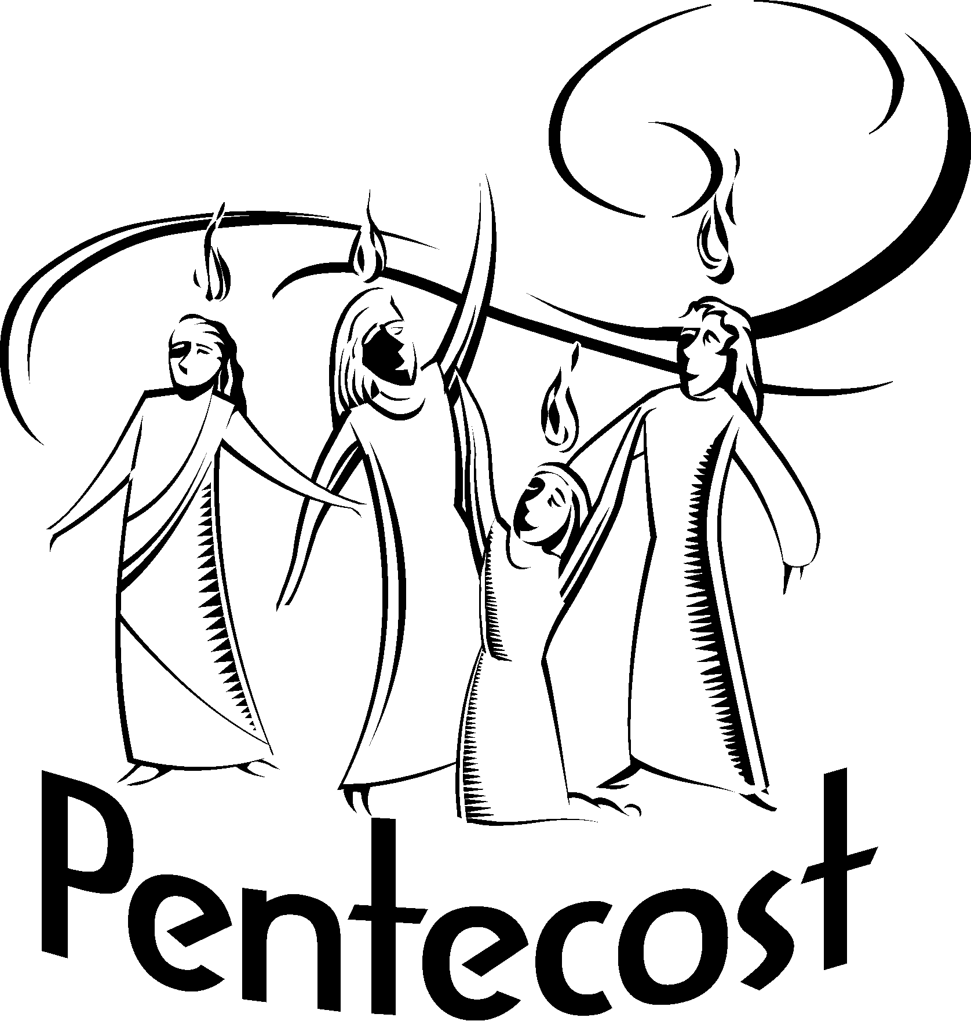
Please join us in worship as we celebrate the gift of the Holy Spirit. Kate
Conolly, our assistant to the Bishop will be here. We will commission
Jane Hill to ministry with the Warrenton church.

Annual Conference is June 16-19
Anne Stark, Mary Frances Gunn, Jane Hill and Pastor Judy will be in Salem
for our annual gathering of all the churches in the conference. Please see the
related article on page 2 for an opportunity to hear one of United Methodist’s inspiring pastors.

June 19 is Father’s Day and worship will be led by you – the laity. Please come.

Two Concerts in Astoria to put on your calendar

** June 9, Epworth Chorale, Potluck at 5:30, Concert at 7. Welcome the singers and hand bell ringers from Boise First UMC (The Cathedral of the Rockies) as they share their music with us. Invite your friends and neighbors to come to the potluck and concert. We still need housing for the youth: two or more per host. You will need to give them breakfast and get them back to the church by 8 am. Please contact Pastor Judy. If you can’t house someone, maybe you can help transport luggage.

** June 26, Sacred Music Concert, 11:30 am. Apprentices from the Astoria Music Festival shared wonderful music with us last year. Please plan to stay after worship June 26 for the concert.
Worship in Astoria will be moved to 10 am that day. Warrenton worship will be moved to 8:30 am.

National Speaker at Annual Conference June 18 in Salem
At this June’s Annual Conference Session we will again have the opportunity to hear from a nationally recognized leader in The United Methodist Church to help inspire us in our local congregations. Rev. Mike Slaughter, pastor of Ginghamsburg UMC in Ohio, will be our speaker at the Annual Conference Leadership Event on Saturday, June 18th at the Salem Conference Center from 8:30 a.m. to 3:30 p.m. His theme is “Change the World: Taking it Out There.” You can learn more about Rev. Slaughter and his congregation at http://ginghamsburg.org But anyone who is interested is welcome to attend as well! The cost is $25. Please see Pastor Judy for scholarship help. More information and registration is available on the Conference website at http://www.umoi.org/pages/detail/148 Rev. Slaughter has written a book called “Change the World: Recovering the Message of Jesus,” which the bishop has suggested we read before the event on June 18th.

Please Pray for
- All with health concerns and Gerry Henry, Kenny Adams, Anne Morden, Audrey Paetow, Jean Curry, Dave Kinman, Dorothy Lindstrom, Gladys Dyer, George and Helen Gunn, Joanne Soderman, Denny Jr., Yvonne Comins, Bernice Winn, Nettie Blair, Alicia Hess, Dr. and Mary Kettlekamp, Rae Estes, Carol Boothe, Trudy Anglim, Sharon Kastl, Laurel Nichols, Bill and Edna Leonard, Charlotte Patching, Jim Swanson, Diane Curs, Mary Ann and Antti Ylipelto, Tom Dyer, Norman Doney, Sharon Wolf, Maxine Dymond, Bruce Dymond, Pam Jenkins, Scott Kindred, Charlie and Nellie Hansen, Bob and Ginnie Tate, Pat Kujala, Carol Clark, Delores Hodney, Joy, Jeff, Jessica and Joseph, Ginny Bynum, Verna Davis, Elizabeth Mannarino, Jewell Smotherman, Rose Marie Thompson, David Robinson. All who are ill and their families.
- Our churches during this time of transition. Pray for Jennifer Mercer and the Astoria church in this in-between time of now and her arrival. Pray for Jane Hill and the Warrenton church.
- The hungry, the homeless, those in prison, those living in violence, those with addictions and their families. Pray for your neighbors and your enemies. Pray for those in disaster areas.
- Pray for our annual conference session June 16-19. Jane Hill, Anne Stark, Mary Frances Gunn and Pastor Judy will be attending.
- Newly baptized Megan and her family.

Special People
- Jeannie Walker, student of the month at Tongue Point. Way to go!!
- Congratulations to the graduates of the Circle of Security.
- Congratulations to the college graduate left off last month’s list: Andrew Kinman.
- All who contributed to Undie Sunday.
- Diane Curs. Diane, thank you for the many, many Sundays of music. You have been an important part of our worship. You remain an important part of our community.

Thoughts from Judy
I find myself excited for the opportunities that lie before the churches in Warrenton and Astoria. I will miss you all. This will be a time of disquiet and unease as new ways of being church are experienced. I, like you, don’t like feeling uncomfortable. When I realize that “fear and worry have made their home in me and anxiety is attending my days, ” I find myself saying, “God, I trust that you are here. I trust you will provide what we need. I will not be afraid, for your steadfast love endures forever.” I say it over and over until I really begin to believe it. May your trust increase in the days ahead. God is with us. Thanks be to God. Amen.
Shalom in Christ, Judy

A Letter from Jennifer

Dear Sisters and Brothers in Christ,

Greetings to the Astoria and Warrenton UMC congregations!

As I write this, I continue to work through housing and moving arrangements, and wrapping up ministry with my churches. There is always so much to do, never enough hours in the day, and stressful moments. I am sure you know what this is like. It’s also a time of living in the uncertainties of the future; I imagine you have experienced times like this, too. Perhaps this period of transition is one of those times for you. It is at times like this that I am reminded of God’s promise to us: no matter where we are, God is with us and has good things planned for our future. It’s a promise I depend on and hold tightly to.

Soon I will join you at Astoria UMC and look forward to greeting you in person and getting to know you. It has been a joy to already learn a bit about your congregation and ministries. God is doing good things through this church and I know God will continue to bless others through your work.

Though there will be time to learn about each other, I imagine you’re curious about me. I was born in Washington, D.C. and have lived most of my life on the east coast. Thirteen years ago I traveled west, living in Nampa, ID then most recently in Vale and Ontario, OR. Though I grew up in the UMC, there were times I worshipped with and explored other denominations, and a time I broke away from the church altogether. For many years, my ministry focus was through worship and music in the local church; then, God led me into pastoral ministry. I especially love leading worship, preaching, sharing our journeys, and sharing God’s Word and love.

I continue to hold you all in prayer during this time of transition. Trust that even in an unknown future, we can depend on God’s promise of good things for us. See you soon!

Blessings,
Pastor Jennifer Mercer
For June 26 only, worship times will change to 8:30 in Warrenton, and 10 in Astoria

Welcoming a new pastor
As Jennifer Mercer arrives, I know you will help her feel welcome. Please remind her of your name the first few times you meet her. Keep her in prayer as she packs and moves. She will probably need help to move into her new home. Invite her to lunch. A welcome gathering will be held in July. Help her to know the routines of the church but allow her to change things just as I did. What I did differently in 2005 when I came is now the norm. That will happen with Jennifer, also.

Saying good bye
While I will still be in the area for a while, once Jennifer gets here, I cannot be your pastor. I will be worshiping at another church and cannot do pastoral duties like funerals. If I see you on the street we can talk, but not about the church. Judy
__________________________________________________________________________

“I have mixed emotions when I receive Father’s Day gifts. I’m glad my children remember me, but I’m disappointed that they actually think I dress that way.”
—Mike Dugan


Day Camp: Be a Hero/ Heroine
Using named and unnamed people in the Bible, we will learn how we, as ordinary kids and adults, can act in ways that raise us above the norm. We can act in ways that can make us heroes (or blessings) to the people that are around us. Day Camp will be August 22 - 25, 9:30 am –2 pm at Shivley Park. Please invite kids who have completed kindergarten through 5th grade. The cost is $20 per child and includes lunch and a snack. Scholarship help is available. We are grateful for your prayers. Let the Astoria office know If you can help with food preparation, transportation, volunteering as a shepherd, or help sponsor a camper for $30.

