Joyful Notes

March 2010

“Open Hearts. Open Minds. Open Doors”

LIFE OF OUR CHURCHES…

Astoria and Warrenton United Methodist Churches
Pastor: Rev. Judy Johnson Diaconal Minister: Jane Hill





March 6 What? You’ve never eaten Pannakaku?
On Saturday, March 6 the Methodist Men will be serving a breakfast for the church featuring pannakakku. This is a Finnish pancake cooked in the oven, part of the Scandinavian heritage. Delicious flavor, served with fruit. Breakfast will be served 9 until 11 a.m. Cost is $5 for adults, $2 kids.

March 14 One Great Hour of Sharing Offering
This special offering provides financial support for the United Methodist Committee on Relief (UMCOR) as they work in the world, on your behalf, to help with disaster relief - both long term and immediate. Shelter, food, water, medical care and spiritual and educational support are what they provide. In Haiti, the United Methodist Church had been present helping with issues of poverty before the earthquake. Executives and volunteers from UMCOR were injured or killed in the earthquake. Your church continues to be there to help. Please continue praying for victims and recovery efforts.

March 14 Daylight Savings Time begins – turn your clock ahead (spring forward).

March 15 Joint SPRC meeting in Astoria, 2:30 pm

March 19-20 Western District Renewal Event: Thrive Where You Are Planted
This three day event is focusing on bringing new life to our churches through worship, mission and service. Pastor Judy and Sue Hicks are going on Saturday. If you would like to join them, let us know soon. There is help with the cost which includes meals. See the bulletin board or talk with Judy.

March 20 60th Anniversary Celebration for George and Helen Gunn, 1-4 pm
Please join Helen and George and family in the fellowship hall in Astoria as they celebrate 60 years of marriage. Congratulations!
March 27 Astoria Work Day, 10 am-12pm
As Easter approaches we will work on the yard
and special places in the church. Bring tools
and gloves. We need You!

March 28 through April 4 HOLY WEEK
Sunday, March 28 is Palm/Passion Sunday We will begin the countdown to Good Friday.
Thursday, April 1 is Maundy (or Holy) Thursday. We will commemorate Christ’s Last Supper with a soup supper at Warrenton UMC at 5:30 pm. At about 6:15 we will have worship with Holy Communion.
Friday, April 2 is Good Friday. There will be an ecumenical worship at noon at First Baptist Church.
Sunday, April 4 is Easter! In addition to our regular worship times (9 am Warrenton, 11 am Astoria) there will be an ecumenical “sunrise” service at the Astoria Column at 7 am. (Nazarene Church if rain.)

The Season of Intention
During the recent conversations about faith and the many ways we live in God’s love, I was impressed by the words people used to talk about “faith”. Many of you spoke about faith being part of your inner core, a reality that had been recognized from an early age and that had been a glowing beacon during the challenges and the celebrations of your life. I celebrate that we have been given free will by God’s grace and that we exercise that free will by choosing to apply the aspects of faith, hope and love to our everyday lives. We intend to be faithful!

When I was getting ready to graduate high school, full of intentions and goals, a dear family friend, Ethel, sent me a card and a note. In her message of encouragement, she assured me that she was praying a “prayer for my intentions” to become a teacher. The word itself describes the process of determining and carrying through with an aim, a purpose or a goal. Ethel’s prayer for me during my teenage years is still her prayer for me – a prayer of support for my choices and of commitment of those choices to God. Her celebration of my active choice set a pattern for me – it validated the process of reflection, prayer, listening for God’s playful suggestions, setting goals and having the patience to move through each of the steps on the journey to meet those goals. She ministered to me by honoring the choices I was making, by dedicating those choices to God’s intention for the world. In this season of reflection on, consideration and celebration of our pilgrimage with God, you are invited to join me in the pondering and celebrating of the concept captured in the word, “intention”.

During this Lenten season, look with love-lit eyes on the people around you – at work, in the neighborhood, during times of volunteering, and in your walking and driving – and pray about God’s intention for each of them. In the lives of our church congregation in Warrenton and Astoria, we are strongly connected to people who are being very intentional in their choices. Every day of the week our buildings are used by people seeking a higher goal – service sororities, quilters, 12-step groups and circles of security for families. Your prayers that those intentions be accomplished gives you the opportunity to make a faith-filled choice to be an active contributor to the process of God’s dynamic creation. When you follow Ethel’s model for those we know personally, you could follow up those prayers with a note to a specific person, letting her or him know how important the choice or intention is to you as part of God’s expression of love. Lent, 2010 – blessed by God to be my season of intention.

Jane Hill

UMW NEWS

Every Member Enrichment Event will take place Saturday, March 13th in Seaside from 10:00 a.m. to 3:30 p.m.. An opportunity to learn about UMW and its many missions. The theme is “Together at the Table” and registration is $7.00 (includes morning refreshment and lunch) or bring your own sack lunch and registration is only $5. Child care will also be provided. A sign up sheet is posted in the Powell Turner Room and car pooling will be offered.

Upcoming RETREAT - save the date: April 13th. The retreat will be lead by our own Jane Hill. This is a mini retreat from 3-7 p.m. at the Benjamin Young Inn.

BEDDING, BOOKS, BAKED & BEYOND … coming June 12th
United Methodist Women are trying something new for our spring fund raiser. We are going to concentrate on selling, as you can see by the above title, bedding, books, baked goods and beyond – which would include plants, table linens, household items such as table and cook ware, vases and other personal treasurers. We also welcome children’s games and toys. If you have plants you can get starts from, these sold great last year. Also, our baked goods sold out last year so hopefully church members will be able to contribute more of their baked goodies.

For this sale we are not accepting any clothing, shoes, purses, hats, etc. Please save your larger household items for the Annual Church Garage Sale in October. Thank you, Astoria’s UMW

2010 Prayer Chain in Astoria
Please review the lists below. Let the office know if you want your name removed or added. In two weeks we will send out a list with phone numbers. Always call the office and Pastor Judy if you are requesting prayer. Leave a message if you don’t get them!!!

PHONE E-MAIL

Bev Aspmo Dorothy Lindstrom Molly Albright
Diane Curs Elizabeth Mannarino Diane Curs

Diane Grumbling Judy Mattson Priscilla Gauthier
Helen Gunn Marla & Josh McConnell Mary Frances Gunn
Deana Hatley Violet Olsen Carolyn Hammer
Carolyn Hammer Charlotte Patching Jane Hill
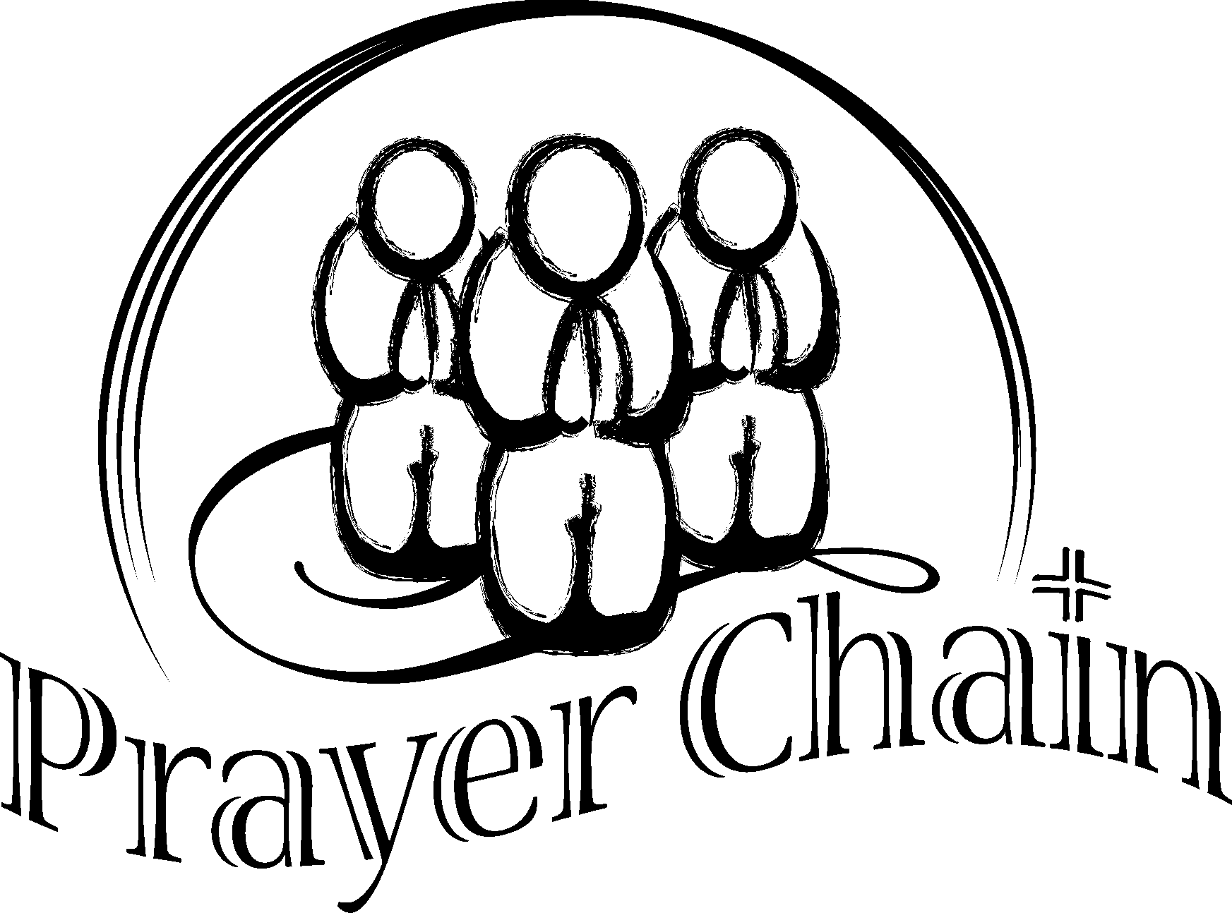
Candy Hendrickson Kathy Patterson Gloria Jones
Jane Hill Joanne Soderman Linda Lane
Laura Hutson Pat Williams Mary Lovvold
Pat Kujala Gerlind Wuepper Anne Morden
Bill Leonard Greta Robinson
Pat Williams
Mary Ann Ylipelto

Please Pray for
- All with health concerns and Linda Williams, Rae Estes, Carol Boothe, Dorothy Lindstrom, Laurel Nichols, Bev Cox, Bill and Edna Leonard, Charlotte Patching, Jim Swanson, Helen Gunn, Diane Curs, Mary Ann Ylipelto, Nettie Blair’s daughter-in-law, Gladys Dyer’s sister, Tom Dyer, Norman Downy, Sharon Wolf, Maxine Dymond, Sylvia Stephens’ daughter Kate, Joy, George Gunn, Pam Jenkins, Scott Kindred, Charlie and Nellie Hansen, Bob Tate, Pat Kujala, Carol Clark, Delores Hodney, Ginny Bynum, Verna Davis, Priscilla Gauthier, Elizabeth Mannarino, Jewell Smotherman, Rose Marie Thompson and her brother, our district superintendent Kate’s mom. All who are ill.
- All who are mourning, and in particular: the Culp family, the family of Al Davis, the family of Tania Houlihan
- People who are living in areas of natural disasters: residents and rescue workers.
- People in transitions. People who have lost their jobs, homes, life savings, self-worth
- People who are depressed, thinking about suicide
- Our nation’s leaders
- All the men and women serving in Afghanistan, Iraq and the Middle East. Kelly, Rose Marie’s grandson
- New parents, single parents, all parents and children. Pray for Marla McConnell as she works with the “Circle of Security” groups meeting in the Astoria church.
- The hungry, the homeless, those in prison, those living in violence, those with addictions
- Please pray for peace
- Please pray to grow in faith and pray for our churches
- Pray for your neighbors and your enemies

******************************
Lord, keep us from taking our time with you casually. May the fire of your Spirit burn within us so all sins are consumed and only joy remains.

Special People
- A word of thanks to the United Methodist Women for the gift of Bibles to Josh McConnell, Chauncey McConnell and Claire Albright. The Bibles were presented January 31 during Astoria’s worship service.
- A special thanks to Rev. Bill Hays and his wife Joyce for sharing the vision and the hope of the Time to Grow Campaign. We were reminded Jesus only asks us to share what we have, and that he will take and bless our resources and make them more than enough. If you would like to make a contribution to the major funds campaign to enhance our camp and retreat ministries and facilities, please contact the office. The goal is to raise 5 million dollars. Your contributions are needed and are tax deductible.
- Jeff Smith for painting the new doors at Warrenton.
- Al Larson for working on the Warrenton yard and taking the old doors away.
- Brain Larson for planting donated bulbs at Warrenton.
- You! For the incredible financial support you faithfully give to both church budgets and special offerings like UMCOR disaster relief in Haiti (over $600 and 11 health kits so far), Pennies for Peace ($276.67 from the birthday party), and gifts to the benevolence fund ($425). You continue to support the food pantries in Warrenton and Astoria. Thank you.
- Bob Gauthier for cleaning up the balcony. Wow, Bob. It looks great!
- All the folks who worked so hard Saturday, February 13. One pancake breakfast in Warrenton and two funerals in Astoria. The day truly was one of shared ministry. With your hands, feet, time and energy, patience, and demonstration of hospitality we could be the blessing to others we pray to be. It was a long day and you are greatly appreciated!!
- In Warrenton: Ginnie Tate, Irene Davis, Jerry Henry, Sharon Wolf, Bernice Winn, Laurel Nichols, Linda Williams, Ann Maize, Gladys Dyer, Kenny Adams, Pastor Judy. Over $300 was raised.
- In Astoria: Bob Hollingsworth, Don Morden, Bob Gauthier, Joanne Soderman, Sue Hicks, Pat Williams, Anne Morden, Gloria Jones, Violet Olsen, Bev Aspmo, Mary Lovvold, Jane Hill, Pastor Judy
- The wonderful people who volunteer to clean our churches. (I hope I don’t leave anyone out.)
- In Astoria; Pat Williams, Sue Hicks, Gloria Jones, Mindy Stokes, Bob and Marilyn Hollingsworth, Linda Grznar, Pastor Judy. We would like to have one more volunteer to clean the Wesley room every week and we could use a few more “occasional” volunteers to cover illness or vacations. Please call the office.
- In Warrenton: Gerry Henry and Ellen Charles who mop the floors, and all the faithful who step into the kitchen and help out.
- The 12-step groups and ALL OTHERS who help keep the areas clean by picking up after themselves and/or reporting something that needs attention. Blessings to all!!!
- Bev Aspmo, Jim and Vera Spain, and Violet Olsen for hosting the recent Astoria conversations. A summary of what was shared will be presented at the March Church Council. Thank you to hosts and all who attended.

************************************
• “Reach up as far as you can, and God will reach down all the rest of the way.”
—John Vincent

• “In the Cross, God descends to bear in his own heart the sins of the world. In Jesus, he atones at unimaginable cost to himself.”
—Woodrow Geier


************************

For the impatient
Pierre Teilhard de Chardin was a French philosopher, Jesuit priest, scientist and author of The Phenomenon of Man. Because Teilhard de Chardin knew people’s tendency to be impatient, he wrote a devotional titled “Waiting” that includes this:
Above all, trust in the slow work of God …. Give our Lord the benefit of believing that his hand is
leading you, and accept the anxiety of feeling yourself in suspense and incomplete.
Above all, trust in the slow work of God, our loving Vine-dresser.

Pastor Judy’s Musings Journey Inward, Journey Forward
Wow! Almost a whole page of “special people.” I’d like to sub-title the column People in Ministry. This whole newsletter is about the ministry of the people in our two churches. Obviously not all people and all ministries are mentioned. But each of you is appreciated in your service (ie ministry) in response to God’s love and grace through Christ.


In this Lenten season, I encourage you to spend time
journeying inward and journeying forward. The phrase reminds me
of walking the labyrinth. As you walk, you step onto a path that moves
you into the center where you can pause and spend quiet time with God.
As you walk you become aware of space and rhythm. As you follow the
path you find yourself near, then far away from the center. I find myself often asking how did I get here? Lent is a time for reflecting on sin and grace, how did I get here in my life and faith journey, and how God continually invites us into relationship with God as the center of our lives. In that center we begin to sense the love, forgiveness and healing that God abundantly provides for us. After time in the center with God, the labyrinth path returns us to the place where we entered. We journey forward into the time and tasks, the people and places that are ahead. The wonderful thing is that God, who awaits us in the center, journeys forward with us. May your Lenten journey be blessed.

During the sermons through Lent we will be focusing on some of what we believe about Jesus, the faith community, rituals and sacraments, our responses to God, and the Trinity. As I think about us as a faith community, the body of Christ - the church - I would like to share a poem by Roberta Porter. She lives in Manzanita and we hope to have her share her ministry of poetry sometime this spring. This poem is published in the January/February 2010 Alive Now. Shalom in Christ, Judy

Gift
By Roberta Porter

It is no small gift to be a faith community,
to worship, to witness,
to walk the way of love
in the name and strength of Jesus.
And in community,
when brokenness and sorrow come,
those in need are surrounded
with prayer and compassion.
Our caring goes beyond ourselves,
and the stranger, in many places,
is touched
by the healing love and grace of God.

In our failures, in our busy forgetting,
we are forgiven, renewed
to continue to be the hands and feet of Christ –
no small task,
no small gift.

When God called your name, God called you to a journey of faith. Do not be afraid to look inside to see those things that are holding you back from being who God created you to be. Place your trust in God who is always with you, loving you into wholeness.

