Joyful Notes

March 2011

“Open Hearts. Open Minds. Open Doors”

LIFE OF OUR CHURCHES…

Astoria and Warrenton United Methodist Churches
Pastor: Rev. Judy Johnson Diaconal Minister: Jane Hill
Administrative assistant: Linda Grznar





Partnering with God: Becoming a Missional Church
Join author Reggie McNeal and fellow Western District United Methodists in this day long event, March 5, 2011 9:30 a.m. – 4 p.m. in Salem, OR.

Safe Sanctuary training March 5
Grace Episcopal Church is offering a daylong training for church leaders that meets the requirements for our Safe Sanctuary training. Safe Sanctuary is the church policy that says the church will be a safe place for children and vulnerable adults. Education is important for all in the church and required of folks working with our children. If you are interested in the training, contact Pastor Judy by Wednesday. The church will pay your fee.

Ash Wednesday Services March 9

Warrenton, 3 pm, Astoria 6 pm
The 40 days of Lent begin March 9 and conclude with Easter April 24. We begin this focused time on Jesus, his love for us, his death and his resurrection with remembering our sin and our need for grace and forgiveness. We place ashes on our foreheads (or hands) as a sign of our mortality and our repentance. Please join us for this short service of reflection and grace.

Reverend Ev Erbele will be our guest March 20 and 21
We have a long-standing mission covenant relationship with Terri and Ev Erbele. From 1996 to 2006, they were in Russia, where Ev helped to develop programs to introduce and educate adults to the Christian faith. From 1999 until June of 2007, Ev traveled in Lithuania and Latvia to foster adult education courses. She was pastor of the Eiguliai United Methodist Church in Kaunas, Lithuania from 2005 to 2007. Organized in 1999, this congregation had a particular focus on at-risk children. Ev wrote and published a study book in both the Russian and Latvian languages entitled, A Biblical Understanding of the Christian Faith and Church Membership through the United Methodist Church. Currently serving in Alaska, Ev is visiting churches in our conference. We will receive a special offering to help pay the costs of her itineration within the Annual conference. Ev will preach on Sunday, March 20, and a potato bar potluck will follow worship. She will lead the women’s retreat on Monday. Please see the UMW article next page for more information about the retreat.

Meals for Circle of Security continue. Thank you to all who are helping with this ministry to families. Check with Anne Morden if you have any questions. Thank you to Carolyn Hammer, Nelson Taylor, Jane Hill, and Pastor Judy for February meals.

March’s volunteers are
March 3 Sue Hicks March 24 Joanne Soderman
March 10 Jane Hill March 31 Sue Hicks
March 17 (open –can you help?)
United Methodist Women
The UMW Spiritual Retreat on Monday, March 21 from 10 a.m. – 2 p.m. at the Benjamin Young Inn is titled, “How many loaves have you?” Guest speaker, Rev. Evelyn Erbele, missionary from Ketchikan, Alaska will be presenting the program based on Mark’s story of Jesus feeding the thousands who gathered to hear him. Ketchikan is similar to Astoria; it is a small community with lots of rain, unemployment and low-income population. A day shelter is located in the 1st Methodist Church’s Social Hall and Rev. Erbele is the church liaison with the shelter manager. All women are welcome to attend this special time for retreat and reflection. Cost for lunch and program is $10. If you have any questions, please call Sue Hicks.
And Don’t Forget
Saturday, March 12th – Every Member Enrichment Event
@ Forest Grove UMC. Car Pooling at 7 am
see Anne Morden or Sue Hicks for more information

Please Pray for
- All with health concerns and Candy Hendrickson, Audrey Paetow, Jean Curry, Dave Kinman, Dorothy Lindstrom, Gladys Dyer, George and Helen Gunn, Joanne Soderman, Yvonne Comins, Bernice Winn, Nettie Blair, Alicia Hess, Dr. and Mary Kettlekamp, Rae Estes, Carol Boothe, Trudy Anglim, Sharon Kastl, Laurel Nichols, Bill and Edna Leonard, Charlotte Patching, Jim Swanson, Diane Curs, Mary Ann and Antti Ylipelto, Tom Dyer, Norman Doney, Sharon Wolf, Maxine Dymond, Bruce Dymond, Pam Jenkins, Scott Kindred, Charlie and Nellie Hansen, Bob and Ginnie Tate, Pat Kujala, Carol Clark, Delores Hodney, Joy, Jeff, Jessica and Joseph, Ginny Bynum, Verna Davis, Elizabeth Mannarino, Jewell Smotherman, Rose Marie Thompson. All who are ill and their families.
- All who are mourning including the families of Sandra Morris and Jessica Maclay
- Our churches during this time of transition. Pray for the person(s) who will be coming to share in ministry in God’s kingdom with you. Pray for Kate, the Bishop and the Cabinet.
- People in transitions. People who have lost their jobs, homes, life savings, self-worth.
- All who are serving our country. Pray for those experiencing post-traumatic distress syndrome. Pray that needed mental (and physical) health services are not cut.
- New parents, single parents, all parents and children. Pray for Circle of Security.
- The hungry, the homeless, those in prison, those living in violence, those with addictions and their families.
- Pray for your neighbors and your enemies.


Please Note

Special People
- All who pledged in Astoria. $63, 870 was pledged to support the ministry and mission of the church. It is not too late to pledge if you have not done so. Thank you to all who faithfully give whether you have pledged or not.
- All who donated to Sophia’s diaper fund. $205 and a box of diapers were given. Thank you to Molly for organizing the great food many of you fixed for the shower. What awesome generosity!!
- Thank you to Astoria’s finance committee for the thank you dinner after worship
Time change

March 13
February 13.
- The workers and the eaters at Warrenton’s pancake breakfast February 5.
Over $500 was raised.
- All who attended or donated to the fundraiser for Alicia Hill Hess. It is truly appreciated.
- You! You who attend worship, donate your time and energies, and keep praying for individuals and your churches.

Astoria Trustees Report

Many of you know of the long-standing problem with the Astoria church roof leaking. We have had many patch jobs over the last six years. The trustees
are recommending we stop patching and re-roof the entire building soon. A
new leak was discovered at Christmas time and the water stains are growing.
We hope structural damage is not being done with so many leaks. Three bids
were obtained and the lowest is $25,040. The finance committee is seeking financing help through grants and loans and other giving. We will keep you informed. Keep praying.

Pastor Judy’s corner

Wow! When I look at how very generous people have been in the month of February, I am awed. I know how I like to give: silly and serious gifts in worship, food or work time at potlucks or other meals, money for budget and special events, money, when I can, to those who come through the church doors with stories of need and faith. I pray for those things I know about and those things I don’t know about. It is a challenge to pray generally, but it is good discipline to trust that God knows what is needed.
And that is true as we move through the next few months. It is good discipline to trust that God knows our needs and will provide. Will we have the money to do what we want and need to do? Will we have the energy and the people to do what we want to do? Maybe a better faith question is, “ Will we trust that God already has given us all we need and will provide the resources to do the ministry that God is calling us to do?” That ministry may not be what we think it is. Are we open to God’s Spirit moving in and maybe changing how we are church? Our churches may change, but God continues to trust in us, that we will continue to be people of faith and action.
If we focus on what we don’t have, we are in BIG trouble. When I look at what we do have, I can only say thank you God for your many blessings. That doesn’t mean we won’t have some challenging moments as things change. We may have to do things differently than we are doing now. A new pastor always means new things in worship and the life of the church. What was new and annoying when I came is now the way we do it. Know there are some adjustments we will be making in the months ahead.
One of these adjustments in the Astoria church is the pending resignation of Diane Curs in June as pianist and organist. We have truly been blessed by her gift of music in our worship time. We will celebrate Diane’s ministry of music at a thank you event that has not been put on the calendar yet. Watch for the date. Be extra blessed by Diane’s music in the coming months.
We are in a dynamic time of change. There is much that is unknown. And there is much that is known. We are people of faith. God is with us. We will not be afraid. And when we are, we will sit with God and find ourselves held and cherished.
For I know the plans I have for you,” declares the LORD,
“plans to prosper you and not to harm you, plans to give you hope and a future. Jeremiah 29:11

Shalom in Christ,
Judy

“Faith is to the soul what life is to the body. Prayer is to faith what breath is to the body. How a
person can live and not breathe is past my comprehension, and how a person can believe and
not pray is past my comprehension, too.” —J.C. Ryle

Statistics are numbers without tears.
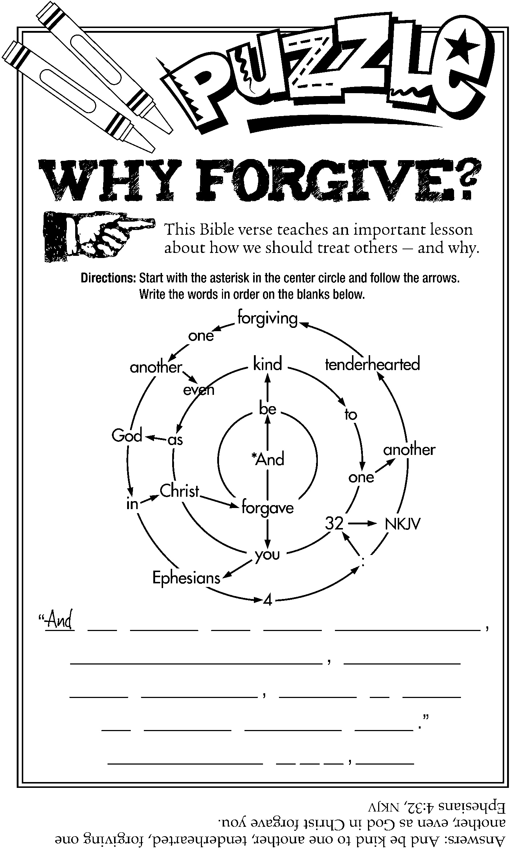

• “The birth of Christ brought God to us, but it took the cross of Christ to bring us to God.”
—Author unknown
• “There is no revenge so complete as forgiveness.”
—Josh Billings
• “The rich man is not one who is in possession of much, but one who gives much.”
—St. John Chrysostom

