Joyful Notes

May 2009

“Open Hearts. Open Minds. Open Doors”

LIFE OF OUR CHURCHES…

Astoria and Warrenton United Methodist Churches







UMW RUMMAGE SALE, May 1 and 2
Remember, the Astoria United Methodist Women’s Rummage sale is
May 1 and 2 from 9 a.m. until 4 p.m. A lunch of hot dogs, chips, and a drink
will be served 11 a.m. – 4 p.m. both days. Setup will begin Monday, April 27.
Please have your clean rummage here by then. All friends and members of the church are being asked to bring a baked food item for the sale.

Sign up sheet for working at the sale is in the Powell-Turner room. Please help. We need YOU to make this a success.

Astoria Church Council, May 3, after worship
Grab your coffee and cookie and come join the continuing discussion about the budget and ministry opportunities. If you have a topic you wish discussed, please let Pat Williams, our chairperson, know.

We continue to work on the format of the meeting and very much want this to be a safe place to discuss concerns and new things that God is putting on your heart about the ministry of Astoria First United Methodist Church. How do we respond to God’s call in our lives? How do we practice being a blessed church? How do we celebrate and use the blessings God gives us?

Mother’s Day Tea, May 9 in Warrenton

One of the groups that uses the Warrenton UMC building is Beta Sigma Phi,
Preceptor Alpha chapter. In appreciation and just for the fun of it, the sorority is
inviting the women of Warrenton UMC and their guests to a tea, May 9 at 2 pm.
You are invited to wear a hat as we celebrate spring and Mother’s Day.
Please let Pastor Judy know if you are coming and if you are bringing a guest.

Pentecost, May 31
Christmas, Easter and Pentecost are the more important Sundays in the Christian Calendar. We recognize Pentecost as the birthday of the Christian church. We celebrate God’s gift of the Holy Spirit to us as we go into the world to proclaim the life and love of Jesus. The liturgical color is red and you are invited to wear something red as part of our celebration.

Descending Dove
The descending dove is a symbol of the Holy Spirit. “As soon as Jesus was baptized, he…. saw the Spirit of God descending like a dove” (Matthew 3:16, NIV). The three-rayed nimbus around the dove’s head identifies the Spirit as a member of the Trinity. A dove shown without the nimbus is a symbol of peace.


Please Pray for
- Those with health concerns: Don Morden, Russell Maize, Norman Downy, Sharon Wolf, Mark Davis, Sylvia Stephens’ daughter Kate, Laurel Nichols and her son Jerry, Waletta Kempt’s daughter Sally, Joy, George Gunn, Pam Hamilton, Scott Kindred, Lori Kindred, Charlie and Nellie Hanson, Maxine Dymond, Bob Butler, Bob Tate, Carol Boothe, Pat Kujala, Carol Clark, Waletta Kempt, Delores Hodney, Ginny Bynum, Al and Verna Davis, Priscilla Gauthier, Elizabeth Mannarino, Jewell Smotherman, Rose Marie Thompson and her brother, our district superintendent Kate’s mom. All who are ill.
- Those who are mourning, including George Gunn and family at the death of his sister-in-law Helen, Chris Oja and family at the death of his mother, David Kinman and family at the death of his uncle.
- Pray that peace, patience, kindness, and trust in God will replace our fears in these stressful times. Pray for the people who have lost their jobs, homes, life savings.
- Children, parents and those who care for them
- Our nation’s leaders
- All the men and women serving in Afghanistan and the Middle East.
- The hungry, the homeless, those in prison, those living in violence.
- Annual Conference and our new legislative process
- The Bishop, the Cabinet, pastors and churches as changes in appointments are made
- Day Camp children and volunteers who will be participating in camp August 10-13.

Special People
- All who participated in the 24 hour prayer vigil and fast on Good Friday: Maxine Dymond, Waletta Kempt, Gerry Henry, Joann Soderman, Gladys Dyer, Irene Davis, Linda Laine, Rosemarie Thompson, Ann Maize, Jim Swanson, Jane Hill, Judy Mattson, Laurel Nichols, Ellen Charles, Nettie Blair, David Kinman, Linda Williams, Molly Albright, Elizabeth Mannarino, Rainy Garland, Mary Frances Gunn, Pat Williams, Pastor Judy, Diane Curs, Gloria Jones, Bernice Winn.
- Judy Mattson for writing the reports about Holy Week activities, Open Door, and the UMW retreat.
- All who participated in Lenten activities, worships and our Easter celebration.
- All who supported our bowlers for the annual United Methodist Men’s bowl-a-thon. Special thanks to bowlers George Gunn, Chuck Albright, Don Morden, Pat Williams, Helen Gunn, Mary Frances Gunn (high scorer) and Sue Hicks. Over $ 440.00 was raised.
- Mindy Stokes who is part of the mentoring program Caring Adults Developing Youth. They have been recognized as volunteers of the year by the county.
- All who brought flowers for the Easter crosses at both Warrenton and Astoria.
- George and Chuck Gunn for dismantling Astoria’s Easter cross. (Nothing worse then dead flowers.)
- Ray Cain for a recent promotion to Lieutenant Commander in the Coast Guard.
- Katrina Gauthier for her athletic talents

• “When I stand before God at the end of my life, I would hope that I would not have a
single bit of talent left and could say, ‘I used everything you gave me.’”
—Erma Bombeck
• “God uses every small act of love for larger purposes.”

UMW RETREAT
Twelve members of our congregation attended the Astoria UMW Retreat “Playing and Singing In the Presence of God” held at the Benjamin Young Bed and Breakfast April 14-15. Carolyn Hammer was a gracious and generous hostess.

Barbara Bate led us in a fun-filled meaningful experience using the Alive Now magazine entitled, “Play”. Readings from the magazine and scriptures from the Bible led to reflective insights and wonderful discussions.

As promised, good food, joyous music, and friendly fellowship were experienced. Games in the evening to get better acquainted were hilarious. All who attended had a great time. This is an event we hope to do again.

OPEN DOOR EASTER PARTY
Twelve of our Open Door friends enjoyed the Easter Party we hosted at their facility. They hunted for plastic eggs containing jelly beans, miniature chocolate bars, money, or gift certificates to McDonalds or Burger King. They decorated boiled eggs and enjoyed a lunch of fish burgers, potato salad, decorated cupcakes and pop.

Special thanks to Mary Perkins who donated the five dozen boiled eggs, Priscilla Gauthier who made cupcakes, Denis and Joanne Soderman who brought and served the lunch, Jane Hill for her financial support, and Sue Hicks who made cupcakes and helped during the entire party.

Our mission to Open Door is well received and greatly appreciated.

MAUNDY THURSDAY SOUP SUPPER COMMUNION
Once again, the Warrenton United Methodist Church outdid itself in hosting the Maundy Thursday Soup Supper Communion Service held April 9. A group of about thirty of us gathered together for conversation, song, spiritual uplifting, and supper.

What a wonderful experience to walk in, be greeted warmly, and smell the aroma of six delicious soups waiting to be tasted. The soups were made by: Gladys Dyer, Bernice Winn, Nettie Blair, Laurel Nichols, Rosemary Thompson, and Pastor Judy. Irene Davis, Gerry Henry, and Ann Davis provided the bread and crackers. Thanks ladies!

Passing the communal bread and juice from person to person made the service even more meaningful. Thank you Warrenton United Methodists, Pastor Judy and Jane Hill.

GOOD FRIDAY COMMUNITY SERVICE
The Good Friday Community Service held at the Bethany Lutheran Church was outstanding. Officiated by pastors of local churches, they did a wonderful memorial service for Jesus. Our own Judy Johnson played the part of Mary Magdalene and was sensational!

GOOD FRIDAY – a personal reflection
Doing a fast on Good Friday and praying for one hour straight made this Easter season especially meaningful for me. I found out I love food and staying away from it is extremely hard for me! It also amazed me that I knew enough people to fill up an hour listing and praying for them!

Thank you, Pastor Judy, for challenging us to do more and to be more Christian.
Judy Mattson


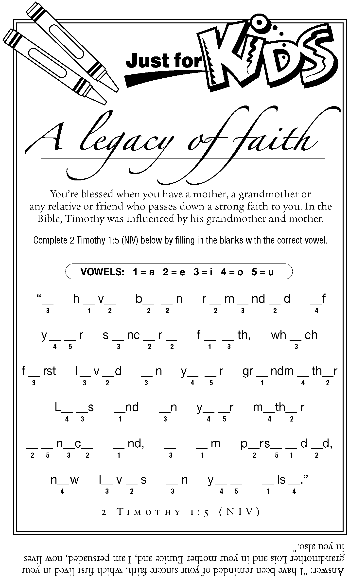

Did you know?
Recently someone asked how much vacation time the pastor receives.
The Oregon–Idaho Annual Conference Rule 1.305 states those under appointment to a local church are entitled to 30 days of vacation at regular pay. There is also provision for leaves for spiritual renewal that are not to be considered vacation: one week a year, one month every quadrennium. (Paragraph 351.2, Book of Discipline.)
Pastor Judy says, I have seldom taken all thirty days and I try very hard to be gone only one Sunday at a time. (So being gone two Sundays in a row is really vacation.) My leave last year was the first time I have taken any leave in 17 years of ministry. Thank you to all for supporting me in needed time off.

