Joyful Notes

May 2010

“Open Hearts. Open Minds. Open Doors”

LIFE OF OUR CHURCHES…

Astoria and Warrenton United Methodist Churches
Pastor: Rev. Judy Johnson Diaconal Minister: Jane Hill
Administrative assistant: Linda Grznar





Two meal opportunities in Astoria
May 2, join us for soup after worship. Your donation will support our youth’s Pennies for Peace project.

May 23, Pentecost Potluck. How many different red food items can we assemble? Following the meal, we will have another all church meeting to continue the discussion begun April 18 about our future. Materials handed out are in the Powell Turner room. This meeting will take the place of the regular monthly church council meeting.



Warrenton’s turn, May 2, 2 pm
If you attend the Warrenton church, you are invited to attend an all church meeting to begin a discussion about our future. We will look at some statistics and talk about future ministry.
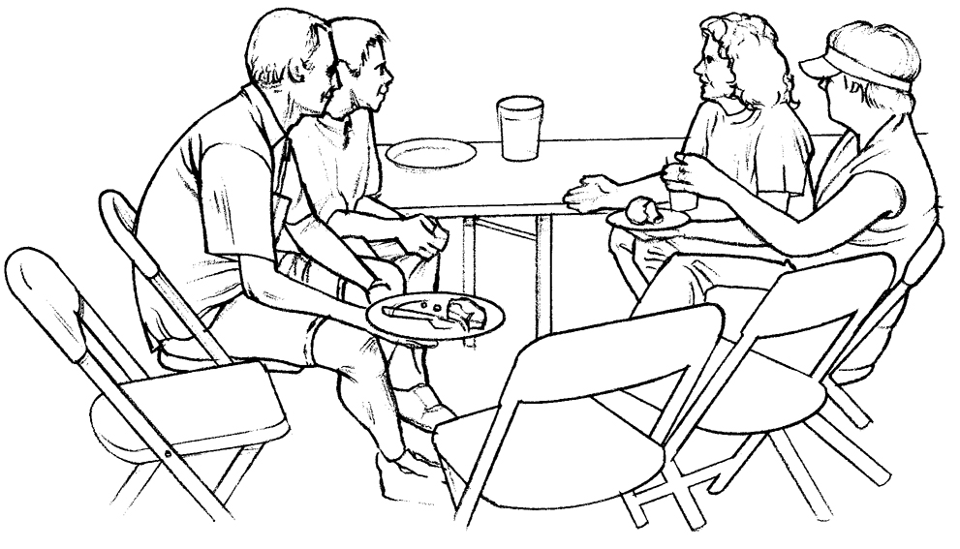

Camp Magruder Workday, May 8
Pastor Judy is planning to volunteer at Camp Magruder on Saturday, May 8. We will be planting flowers throughout camp and maybe some other chores like window washing. If you would like to help or donate some flowers to plant, please see Judy.
Graduate Recognition, May 16 in Astoria
Please notify the office of any graduates and then, please come help celebrate
their accomplishments during worship. Our United Methodist Women will host the reception to follow.

Pentecost, May 23
We celebrate the birthday of the church on Pentecost. Please wear something red. (For Astoria folks, we will also be having a potluck after worship. Bring red food.)

Fifth Sunday Sing, May 30, 6:30 pm
Join Diane and Mary Frances as they lead us in some grand singing. We may be small but we are good! Note the 6:30 time.
Please Pray for
- All with health concerns and Bernice Winn, Nettie Blair, Roger Platt, Dr. and Mary Kettlecamp, Irene Davis, Linda Williams, Rae Estes, Carol Boothe, Trudy Anglim, Ginger Ponton, Dorothy Lindstrom, Laurel Nichols, Bev Cox, Bill and Edna Leonard, Charlotte Patching, Jim Swanson, Helen Gunn, Diane Curs, Mary Ann Ylipelto, Nettie Blair’s daughter-in-law, Gladys Dyer’s sister, Tom Dyer, Norman Doney, Sharon Wolf, Maxine Dymond, Sylvia Stephens’ daughter Kate, George Gunn, Pam Jenkins, Scott Kindred, Charlie and Nellie Hansen, Bob Tate, Pat Kujala, Carol Clark, Delores Hodney, Joy, Jeff, Winnie, Ginny Bynum, Verna Davis, Priscilla Gauthier, Elizabeth Mannarino, Jewell Smotherman, Rose Marie Thompson and her brother, our district superintendent Kate’s mom. All who are ill.
- All who are mourning, and in particular: the family of Carol Kindred, the family of Robert Black
- Ola Labiske who has moved to a foster home in Warrenton. Please call the office for her address.
- Day Camp – August 9-12. Please pray for the children and the volunteers
- Churches in transition as pastors change. Our Annual Conference as it reorganizes.
- People in transitions. People who have lost their jobs, homes, life savings, self-worth
- People who are depressed, feel isolated, thinking about suicide
- Our nation’s leaders
- All the men and women serving in Afghanistan, Iraq and the Middle East. Kelly, Rose Marie’s grandson
- New parents, single parents, all parents and children. Pray for Marla McConnell as she works with the “Circle of Security” groups meeting in the Astoria church.
- The hungry, the homeless, those in prison, those living in violence, those with addictions
- Please pray for peace
- Please pray to grow in faith and pray for our churches
- Pray for your neighbors and your enemies

Special People
- All who brought flowers and greenery for the Easter crosses at Warrenton and Astoria. Special thanks to George and Chuck Gunn for pre-preparing the Astoria cross on Saturday. Thank you to Linda Grznar for help dismantling the Astoria cross, and David Nichols in Warrenton.
- The soup and bread bringers for Maundy Thursday soup supper in Warrenton: Bernice Winn, Nettie Blair, Anne Stark, Gladys Dyer, Irene Davis, Anne Maize, Gerry Henry, Pastor Judy
- Readers for Palm/Passion Sunday: Nettie Blair, Irene Davis, Jim Swanson, Anne Stark, and Sharon Wolf in Warrenton; Ellen Charles, Sue Hicks, Diane Curs, Charlotte Patching, Denis Soderman, and Laura Hutson in Astoria
- Joanne Soderman for organizing the prayer chain in Astoria. If you are on the phone prayer chain, you should have received a letter with who to call. Please call the office if you want to be added to or removed from the phone list or your phone number is incorrect. Also we have an email list and we can add your name to that list. Call Joanne and the office to start the prayer chain. Please leave messages if no one is available.
- The AA folks in Warrenton who will be cleaning the church in May. THANK YOU!!
- Those who support our churches in so many ways.
Jane’s Corner: 

Have you noticed that Spring is bursting out all over? The lovely glowing green of new growth, the exploding colors of the flowers and the birds’ songs all affirm the dates on the calendar – we are in Eatertide! The energy of new beginnings and hopefilled anticipation surround us. Have you noticed that God’s love is bursting out all over? Nature nudges us to pay attention, to see, smell, feel and hear the work of the Holy Spirit. It is a time for thankfulness and we are grateful for each of the opportunities available to us as we serve our Lord in our everyday, walking around life. I am particularly grateful for the ministries of our children and youth and ask that you join me in lifting up our thanks to God for these blessings that wash over us like the spring rain.

We celebrate that our prayers for children and their families to be present with us have been answered! The parade of smiles and energy that join our Pastor for children’s time each Sunday make us joyful. We are so grateful to the parents and friends who make it possible for the children to be with us.

The ministry of the Sunday School classroom helps connect the time with us to the other parts of these children’s lives. Katrina, Elizabeth and others help each Sunday morning become a special learning and creative experience.

The Pennies for Peace project teaches the power of local action connecting to needs in distant lands—children need teachers and schools here and there and everywhere! Your pennies, smiles, cupcakes and prayers are all part of this connecting love. Josh and his team of workers are awesome.

And now, in response to the need for health kits after earthquake disasters, Claire Albright and her family have invited others at the Seaside Heights School to put together needed supplies.

Keep your heart and ears open for even more instances where we are lead and inspired by our children and their families. There is joy in service, in leadership and in good hard work – there is gratitude and grace. We are all blessed and we offer that blessing to others. We are Easter People of all ages and we combine our efforts to worship and serve our risen Savior. Ya-Hoo!!! God is with us!

Food Bank Focus
The food bank sure could use some canned fruit, especially peaches. Can you help?
Monetary donations and other items such as cold cereals and personal hygiene items are always appreciated.



UMW News

Bedding, Books, Baked and Beyond… coming June 12th
Be sure to start collecting gently used or new bedding, books, and beyond – which would include plants, table linens, household items such as table and cook ware, vases, children’s games and toys, and other personal treasurers. Plants and plant starts sold well last year. Also, our baked goods sold out. Hopefully church members will be able to contribute more of their baked goodies.

For this sale we are not accepting any clothing, shoes, purses, hats, etc. Please save your larger household items for the Annual Church Garage Sale in October. Thank you, Astoria’s UMW

DAY CAMP
Calling out to all who are planning on and interested in being part of the 2010 Day Camp for children!

Camp will be held at Shivley Hall in Astoria during August 9-12, 2010. It is time for all of us to get together with the planning group and to hear about all the great plans and possibilities for this year’s Day Camp. This is for people who want to work with the children and the supporting teams during the Day Camp.

We want to schedule an evening meeting, 7-8:30 p.m. for sometime during the week of May 10-17. Right now, we want to know if it is most convenient for you to attend on Monday, Tuesday, or Thursday night. Call Jane at 503-458-6633 or leave a message at the church office to let us know which evening works best for you.

We particularly need a person to supervise and organize the craft supply part of the Day Camp. This person would organize all our efforts to gather the material necessary and make them available for the planned crafts. If you are interested and willing to help in this effort, let us know, please.

If you are not able to work directly with the children, watch for more announcements about other ways to get involved and be supportive during the next months – there will be opportunities to pray, provide camp scholarships, provide supplies and to help us “spread the word”.

Warrenton news
- At the last Administrative Council meeting, we began discussing painting the outside of the church. There are paint bubbles/blisters that contain water and are damaging our wood. Also the mold is again building up. We will be seeking bids.
- There are just a few more details to accomplish to finish the sump pump installation.
- It was brought to our attention that one person had to sit outside the sanctuary on Easter because of her respiratory symptoms from all the flowers. It was suggested that next year we try to find another way to decorate the cross.

Pastor Judy’s Ponderings

I believe that I shall see the goodness of the Lord in the land of the living! Psalm 27:13

I am truly blessed by the goodness that I see in our churches. We are not perfect. We do have our moments of irritation. But more abundant is the goodness of your gentle and generous hearts. As we approach the celebration of the birthday of the church called Pentecost, may we give thanks for our part of being the body of Christ. I do see the goodness of the Lord in you. Thanks for being part of my ministry. Remember to wear red May 23.
Blessings, Judy

Planting for the harvest … by Anonymous Chinese Poet, 500 BC

If you are thinking a year ahead, sow seed.
If you are thinking ten years ahead, plant a tree.
If you are thinking one hundred years ahead, educate the people.



SIGN UP FOR SERVICE!
We need worship assistants, liturgists, greeters, coffee hosts, etc.
Please see the bulletin board in the Powell Turner Room
and add your name.

Stewardship and Finance
“One of the gifts my predecessor left taped to my computer monitor is the familiar admonition of John Wesley:
‘Do all the good you can, by all the means you can, in all
the ways you can, in all the places you can, at all the times
you can, to all the people you can as long as ever you can!”
In his book, Three Simple Rules, Bishop Job offers this reflection: ‘The words of Jesus and of Wesley suggest that doing good is a universal command. That is, doing good is directed at everyone, even those who do not fit my category of ‘worthy’ to receive any good that I or others can direct their way. This command is also universal in that no one is exempt from it.’ (p. 37)
Giving to our Shared Ministries is a tangible way to extend this “doing good” to those in need through our local projects, our national ministries, and our global missions. It reflects the faith we have in God’s extravagant abundance, even in the face of economic challenges. Thank you for your faithfulness. Bill Mullette-Bauer, Director of Stewardship and Finance

Thank you for your gifts. Your generosity is truly amazing and I am so gratefulto be your secretary. You have taken me into your hearts and wrapped me in blessings. You shine with Christ’s love and I am graced to be in your service. Alleluia! Linda

IF MY BODY WERE A CAR …
This is the time I would be thinking about trading it in for a newer model. I’ve got bumps and dents and scratches in my finish and my paint job is getting a little dull – but that’s not the worst of it.
My headlights are out of focus and it’s especially hard to see things up close.
My traction is not as graceful as it once was. I slip and slide and skid and bump into things even in the best of weather.
My whitewalls are stained with varicose veins.
It takes me hours to reach my maximum speed. My fuel rate burns inefficiently.
But here’s the worst of it …
Almost every time I sneeze, cough or sputter … either my radiator leaks or my exhaust backfires!

… shared by Nehalem Bay UMC

CHANGE HUNGER FAST Campaign
May 9 – June 6

United Methodist churches will be collecting change during our Sunday worship services from Mother’s Day through June 6 for the Bishop’s annual Change Hunger Fast campaign. The monies will then presented to Annual Conference. Let us show the world that God can count on us to be his hands of service in serving the needy.



