Joyful Notes

November 2009

“Open Hearts. Open Minds. Open Doors”

LIFE OF OUR CHURCHES…

Astoria and Warrenton United Methodist Churches
Pastor: Rev. Judy Johnson, Diaconal Minister: Jane Hill





Astoria Halloween Breakfast Fundraiser, Saturday, October 31, 7-11


Plan to join your friends at breakfast, Saturday morning, 7-11,
October 31 at the Astoria church. Pancakes, eggs, ham, juice and coffee. You are invited to come in costume (or not).
Cost $5 for adults. $2 for kids under 10.
(Remember to support your church: pray, participate, invite.)



Sunday, November 1, All Saints Day
Change clocks – fall back. Turn clocks back an hour.
During worship, we will lift up the names of those who have died this past year and remember others.


Two Great Bazaars
Crafts, baked goods, new to you table
November 7, Warrenton United Methodist Church
10-2, Lunch 11-1

November 14, Astoria First United Methodist Church
10-2, Lunch 11:30-1
Our famous cookie walk

Sunday, November 29
First Sunday in Advent
Fifth Sunday Hymn Sing, 4 pm.
(Note time change.) We will share cookies and spiced cider, carols and hymns. Bring canned food for the food pantry. Invite a neighbor.
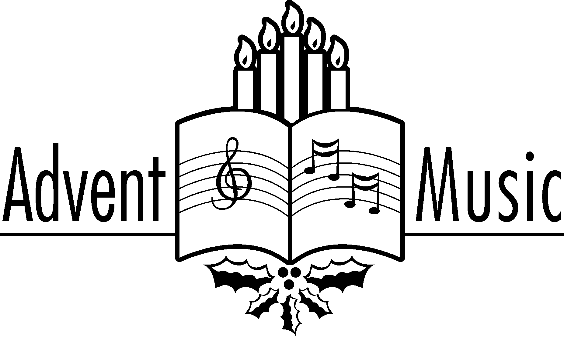


How To Survive the Holidays: A Wellness Seminar
Join us for a series of three seminars focusing on wellness during the holiday season. (Continued on next page.)

How To Survive the Holidays: A Wellness Seminar (continued from first page)
Mindy Stokes and Pastor Judy will focus on financial, nutritional, and spiritual-mental wellness during what is, for many, a stressful time. Meetings will take place on Thursdays, 6:30-8 pm in the Wesley Room at the Astoria church. November 5 will focus on financial wellness, November 12 on nutritional wellness and stress management, and December 3 on grief and spiritual wellness during the holidays. These meetings are free and the public is welcome. We will be scheduling a low-cost craft event for families in December. Please see Pastor Judy if you want to help or have suggestions. To be sure we have enough handouts, please let us know if you are coming.

Thoughts from Jane
November and Thanksgiving blessings to all of you. I find myself doing "spring cleaning" in the fall of each year, as the leaves transform the ground and the yard, and birds gorge themselves--I dig around in the closets! This year I have been invited by the owner of a Astoria historic picture business to locate and share some of mother Ruth Hansen Maki's 19th and early 20th century photos. In the process of that search and recovery effort, I ran across this prayer and wanted to share it for thoughtful consideration. At this point in my life, I know it is written for me--and for all of us who are "older adults" in ministry right here and right now!
PRAYER FOR THE OLD AND THE YOUNG
"Lord, you know me better than I know myself. I am seeing more and more candles on my birthday cake and will someday actually be old! Keep me from the fatal habit of thinking I MUST say something on every subject and on every occasion. Show me how to be gracious to new folks, without drowning them with my own testimony. Release me from craving to straighten out everybody's affairs. Make me thoughtful but not moody, helpful but not bossy.
Help me set aside my desire to bring up the past as if no one else has lived through experiences from the "old times". With my vast store of wisdom, it seems a pity not to use it all, all the time, but You know, Lord, that I want to have a least a few friends who enjoy being around me at the end of my life.
Keep my mind free from the recital of endless details; give me wings to get right to the point in my conversations. Seal my lips about my aches and pains. Yes, those aches and pains are increasing and I know the love of rehearsing them is becoming sweeter to me as the years go by. I dare not ask for grace enough to enjoy the tales of other's pains, but help me to endure them with patience. Help me listen five times longer than I speak.
I dare not ask for improved memory, but for a growing humility and lessening cocksureness when my memory seems to clash with the memories of others. Remind me that I am not the only person who has had precious encounters with God. Teach me the precious and glorious lesson that, occasionally, I may be mistaken.
Keep me reasonably sweet--I do not want to be a saint because some of them are so hard to live with. Help me remember that a sour old person is one of the crowning works of the devil. Give me the ability to see good things in unexpected places and to honor the talents God has placed in unexpected people. Finally, Lord, give me the grace to tell others how much I see God working through them, not through me. Hear my prayer, dear Lord. AMEN
Grace and peace to all of you, Jane Hill
• “Thanksgiving was never meant to be shut up in a single day.”
—Robert Caspar Lintner
• “A coincidence is God’s way of remaining anonymous.”
—Unknown
Please Pray for
- Those with health concerns: Jim Hill, Bob Butler, Don Morden, Diane Curs, Mary Ann Ylipelto, Lori Kindred, Irene Davis, Russell Maize, Norman Downy, Sharon Wolf, Sylvia Stephens’ daughter Kate, Laurel Nichols and her son Jerry, Joy, George Gunn, Pam Jenkins, Scott Kindred, Charlie and Nellie Hansen, Maxine Dymond, Bob Tate, Carol Boothe, Pat Kujala, Carol Clark, Delores Hodney, Ginny Bynum, Al and Verna Davis, Priscilla Gauthier, Elizabeth Mannarino, Jewell Smotherman, Rose Marie Thompson and her brother, our district superintendent Kate’s mom. All who are ill.
- All who are mourning, and in particular: the family of Waletta Kempt and the family of Sylvia Laine.
- People who are living in areas of floods, earthquakes, other natural disasters
- People in transitions
- Pray that peace, patience, kindness, and trust in God will replace our fears and will continue to empower us to help people in need in practical ways. Pray for us to be open to the Holy Spirit.
- Pray for the people who have lost their jobs, homes, life savings, self-worth
- Our nation’s leaders
- All the men and women serving in Afghanistan and the Middle East.
- The hungry, the homeless, those in prison, those living in violence, those with addictions

Special People
- All who honored Waletta by helping with preparation and clean-up for the reception after her memorial service. Thank you!
- All who faithfully serve in so many ways in the church. Your service reflects your love for God and the Christ with-in you.
- For the many who helped lead worship on Laity Sunday. There is no church without laity. You are an essential part of God’s kingdom as you practice being a bold disciple of Christ.
- Jane Hill for preaching so I could participate in the Great Columbia Crossing. It has been a blessing to be in worship as a person in the pew and not a worship leader.
- All who helped with the garage sale and the cupcake sale. The garage sale raised around $1500.

WOW! Cupcake success: $ 339.25
Who would have predicted the support and outcome of the cupcake sale that Josh McConnell, Katie Patterson, Claire and Abbey Albright held for Pennies for Peace. This project, described in the book Three Cups of Tea: One Man’s Mission to Promote Peace, One School At A Time, by Greg Mortenson and David Oliver Relin, is a mission outreach to help provide education for children in Afghanistan and Pakistan. A big thank you to the kids for caring for children they will never meet.. Another thank you goes to everyone who baked and donated funds. Special kudos to Harriet Hugo for her 90 cupcakes. You all demonstrated to our younger church members how generous we can be. You showed the church in action – making a difference in someone’s life.

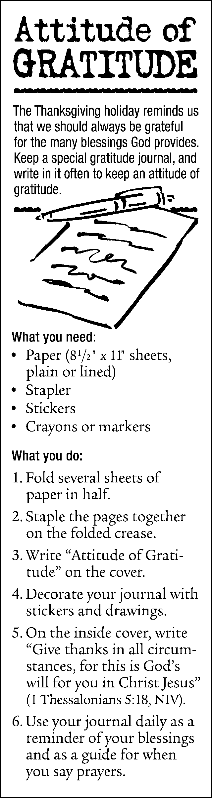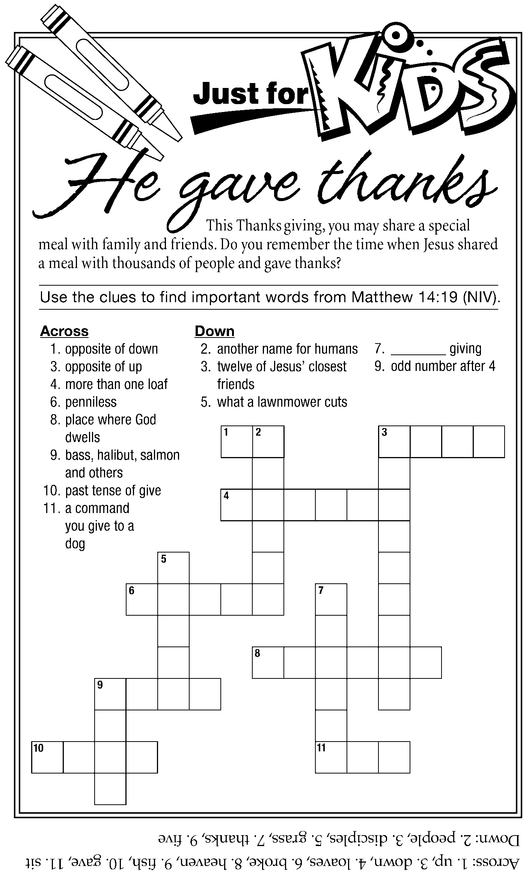

Three kinds of giving
“There are three kinds of giving: grudge giving, duty giving and thanksgiving. Grudge giving says, ‘I have to’; duty giving says, ‘I ought to’; and thanksgiving says, ‘I want to.’ The latter comes from a full heart. Thanksgiving is an open gate into the love of God.”
—Robert N. Rodenmayer

Wash Your Hands!!
“Be not afraid. Jesus is more powerful than germs.” That’s the advice from The United Methodist Church’s agency charged with providing leadership and resources to local churches in the face of the country’s concern over the H1N1 flu virus.
“Do celebrate worship and the sacraments fully and be not afraid,” said Taylor Burton-Edwards, director of worship resources for the United Methodist Board of Discipleship. “Use common sense, but remember this: Jesus is more powerful than germs!”

Taking normal precautions against spreading germs helps us and others. The primary ways the virus spreads is by airborne particles from coughs or sneezes and by skin-to-skin contact with someone who is infected, according to the U.S. Centers for Disease Control and Prevention. Cover your cough and try to do so with a tissue or your sleeve rather than your hand. Wash your hands often. In fact, you should be washing your hands up to 10 times a day: before preparing food, after going to the bathroom, after sneezing or coughing, after handling a diaper, used tissue or used band aid, or touching surfaces that have been touched by a lot of people – doorknobs, carts in a store, counters, etc. Wash from fingers to wrists for 20 seconds - the amount of time it takes to sing Happy Birthday twice. Use a cloth handkerchief only once. Use liberal amounts (2 squirts) of hand sanitizers that contain above 60-percent alcohol. Cover your whole hand and rub until completely dry.

If you think you might have a cold or are concerned about getting one, wave or nod rather than shaking hands when greeting others. If you have the flu or other serious illness, please stay home and rest. If you volunteered to do something, call the church and explain you won’t be there due to illness. It is better for people to be disappointed by our absence rather than to be sick with the flu.

A scientist did a study comparing those who regularly attended church and received Holy Communion with those who did not. There was no difference in the illness rates between the two groups. Even so, there are two common sense precautions to take during Holy Communion: do not touch the loaf of bread unless you have just washed your hands and keep your fingers out of the grape juice.

Taking basic, common sense health precautions is one way we care for each other. However, it is just as important to avoid becoming obsessed with germs or isolated by fear. Joining with others for worship, fellowship, and service provides tremendous benefits for our emotional, physical and spiritual well being. Please let us know your concerns and suggestions.

Judy’s corner
Recently I attended a workshop on “the five practices of a fruitful congregation.” The image raised is one of a church making a difference in the life of someone outside the church walls as well as someone already attending church. The practices involve radical hospitality, passionate worship, intentional faith development, risk-taking mission and service, and extravagant generosity. I started wondering about whether the church is making a difference in your life. Has your faith grown in the last year? What are you measuring to give you your answer? How would you rank us on the five practices? How would you rank yourself? I know I have room for growth. And that is good. I am excited about the possibilities and challenges that God is presenting to me, and to us, to grow in practices of discipleship, and thus to grow in faith. We will have a grand time practicing together.



Santa’s Workshop Bazaar
and Cookie Walk



First United Methodist Church
1076 Franklin Ave., Astoria
Sat., November 14, 10 a.m. – 2 p.m.

Cookie Walk
Assorted Selection of
Hand Crafted Christmas Gifts

Luncheon: 11:30 a.m. – 1:30 p.m.
Adults $8.00 Children $3.50

Menu:
Traditional Turkey Casserole
Garden Salad
Roll, Pie and Beverage

