Joyful Notes

October 2010

“Open Hearts. Open Minds. Open Doors”

LIFE OF OUR CHURCHES…

Astoria and Warrenton United Methodist Churches
Pastor: Rev. Judy Johnson Diaconal Minister: Jane Hill
Administrative assistant: Linda Grznar






Join us October 3
for this special Communion celebration.
Please wear something that represents another country.

Astoria Garage Sale just around the corner: October 15 – 16, 10 - 4

Your clean, in good condition items are needed now for the garage sale.
Harry Comins and Jim Robinson will be setting up early. They will need
help before and on the days of the sale. It is REALLY HELPFUL if you
can get your items in early for pricing and display.
Please no TV’s, clothes or items that need repair.

Pennies for Peace Cupcakes
Our fabulous kids will again be raising money for Pennies for Peace during the garage sale. They will be “selling” cupcakes. i.e., you make a donation. These monies fund a teacher for schools in Afghanistan as reported in the book Three Cups of Tea. Thanks for your past support.


Save the Date!! October 17, Astoria Charge Conference
Rev Scott Allen will join us for worship and then the charge conference will immediately follow.
Required reports will be shared and the salary for Pastor Judy will be set. This is an important meeting. Please plan to stay. Our Assistant to the Bishop, Rev. Kate Conolly (formerly District Superintendent), will visit at a later date to have conversation with us about the state of the church. If you are a committee head, reports are due in the office, October 1.
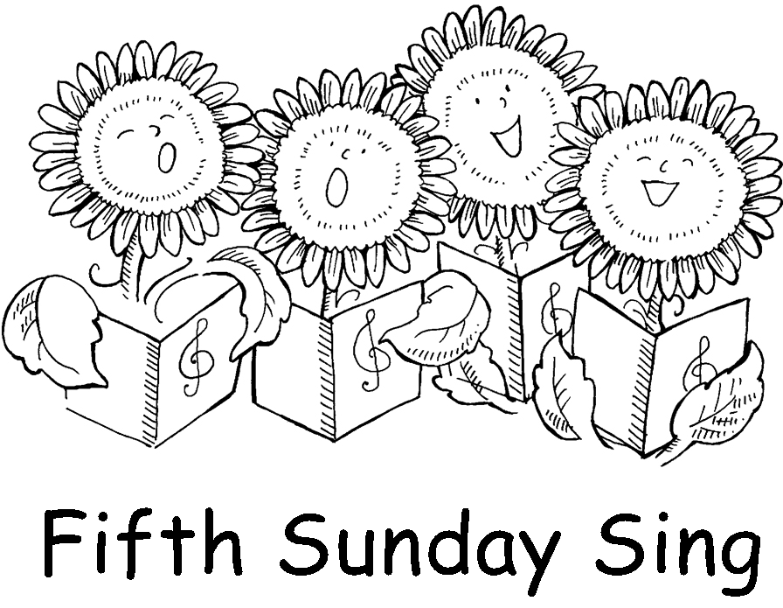

Fifth Sunday Sing October 31
Another great chance to sing your favorite hymn. Join us at 6:30 pm.
Since it is Halloween, maybe you will get a treat. Come find out!

Important opportunity on next page→

Immigration Discussion October 2

Come and have lunch with folks from Seaside, Warrenton and Astoria. Your host will be the Astoria United Methodist Women. Help us to welcome our special guests Carol Johnson, Conference President of United Methodist Women, Ron and Kathy Whitlatch, conference missionaries, Norma Hernandez director of the Lower Columbia Hispanic Council and the president of their board of directors, Maria Zavalza.

This special meeting will begin at 10am, October 2^{nd,} with a UMW business meeting in the fellowship hall The program given by Ron and Cathy Whitlatch will begin at 11 am. They will speak from personal experience about the United Methodist Church’s and United Methodist Women’s stance on immigrant, human and civil rights. Following the program we will adjourn to lunch.
All members of the church are welcome. Please let Mary Lovvold know if you are able to attend.

Also keep on your calendar the Annual Meeting of the UMW in Pendleton on Saturday Oct. 23rd.
Janice McLain will be keynote speaker and there will be a speaker via sky cam from UMCOR Depot West. The afternoon will be spent with “hands on” mission projects. Registration is 8 a.m.


Please Pray for
- All with health concerns and John Williams, Don Morden, Gladys Dyer,
Joanne Soderman, Yvonne Comins, Deana Hatley, Bernice Winn,
Nettie Blair, Jim Hill, Alicia Hess, Sue Hicks, Dr. and Mary Kettlecamp,
Irene Davis, Rae Estes, Carol Boothe, Trudy Anglim, Sharon Kastl,
Dorothy Lindstrom, Laurel Nichols, Bill and Edna Leonard, Charlotte Patching,
Jim Swanson, George and Helen Gunn, George’s sister Ruth, Diane Curs,
Mary Ann Ylipelto, Nettie Blair’s daughter-in-law, Gladys Dyer’s sister, Tom Dyer, Norman Doney, Sharon Wolf, Maxine Dymond, Sylvia Stephens’ daughter Kate, Pam Jenkins, Scott Kindred, Charlie and Nellie Hansen, Bob Tate, Pat Kujala, Carol Clark, Delores Hodney, Joy, Jeff, Jessica and Joseph, Winnie, Ginny Bynum, Verna Davis, Bob and Priscilla Gauthier, Elizabeth Mannarino, Jewell Smotherman, Rose Marie Thompson and her brother, our district superintendent Kate’s mom. All who are ill and their families.
- All who are mourning, including Mindy Stokes at the death of her uncle
- All with difficult decisions
- People in transitions. People who have lost their jobs, homes, life savings, self-worth
- People who are depressed, feel isolated, thinking about suicide
- Our nation’s leaders
- Those affected by the oil spill and flooding
- All who are serving our country
- New parents, single parents, all parents and children. Pray for Marla McConnell as she works with the “Circle of Security” groups meeting in the Astoria church.
- The hungry, the homeless, those in prison, those living in violence, those with addictions and their families
- Please pray for peace
- Please pray to grow in faith and pray for our churches
- Pray for your neighbors and your enemies

Special People
- Lieutenant Commander Ray Cain, retiring from the Coast Guard.
- Karen and Doris Wright for their hospitality for a potluck in Warrenton. Despite the rain, we had a great time.
- Josh McConnell who is helping with the Children’s Sunday School. Other adults are needed to help with this important ministry with our kids. Contact Elizabeth Mannarino to volunteer.
- All who blend their voices at the Fifth Sunday Sing. Special thanks to Diane Curs and Mary Frances for their leadership. Come join us October 31 at 6:30 pm and see what all the joy is about.
- All who continue to bring food for the food pantries. Thank you! Thank you! Cold cereal, protein items, fruit, and things used in bathrooms are always needed.
- The many who come to meetings. Your time and commitment to the church is appreciated.
- You. You are cherished by God and held in prayer. Thank you for being generous and faithful.
- All who register and vote.

Thoughts from Pastor Judy
We are on the road, and oh, my God, what great things we will find!
At the spiritual retreat I attended last week, we read out loud all the Gospel lessons for the coming year, starting with Advent (November 28, 2010) and going through Christ the King Sunday (November 20, 2011). It took us a day and a half, including meals, sleep and a few other activities. As we reflected upon God’s word in Matthew and John, I really became aware of the connection over and over with the journey of the folks in the Old Testament. The journey of creation, sin, deliverance, good days, bad days, people full of faith, people making poor and hurtful decisions - a journey with God. The journey with God between Adam and Eve and Jesus. The journey with God between Jesus and us today. The journey with God between us today and our churches in a future we do not know and cannot imagine. When we take the time to reflect, we know that God is in the past, in our present and is already gone before us. God is with us when we don’t know what our next step should be. God is with us when we misstep. And God is with us when the way is smooth and sure. I found myself reflecting on my own journey and thinking about aging and dying and change and loss. Not in despair but in thankfulness that there is a God given cycle to creation that links us all to the past and future. If I get bogged down by thoughts and reality of an aging body, potentially declining physical and mental abilities and depression that I am no longer 30 (my best year), I know that I will not be seeing the blessings from God that are all around me. And so, a theme came to me: I am on the road, and oh, my God, what great things I will find. This will remind me to look for God on my journey, even if the way is hard. To be thankful for something each day and to reach out to another. And then as I reflected on the year ahead and the ministry we will do together, I rewrote the sentence to say:
We are on the road, and oh, my God, what great things we will find!
We are so blessed – and challenged at this time in the life of our churches. May we have the confidence to trust God in stepping into the future and finding great things on our journey, even when the way seems discouraging and unclear. God is with us and we will find great things.
Blessings and Shalom in Christ.
Judy
A Christian at a retreat center saw this sign on a walkway path: "Don't just do something. Stand there."
The sign hinted of Psalm 46:10 (NRSV): "Be still, and know that I am God!" Only by being still can we sense God's presence and know him intimately. Experiencing calmness requires taking frequent respites from our feverish lives.


Humility and Hospitality - Always remember that there are two types of people in this world. Those who enter a room and say, ‘Well, here I am!’ and those who come in and say, "Ah, there you are!"

Positive Thinker Corrective - Humble people don’t think less of themselves . . .
they just think about themselves less. (Norman Vincent Peale)

Too humble is half proud (Yiddish Proverb)

