Joyful Notes

September 2009

“Open Hearts. Open Minds. Open Doors”

LIFE OF OUR CHURCHES…

Astoria and Warrenton United Methodist Churches





Come One, Come All
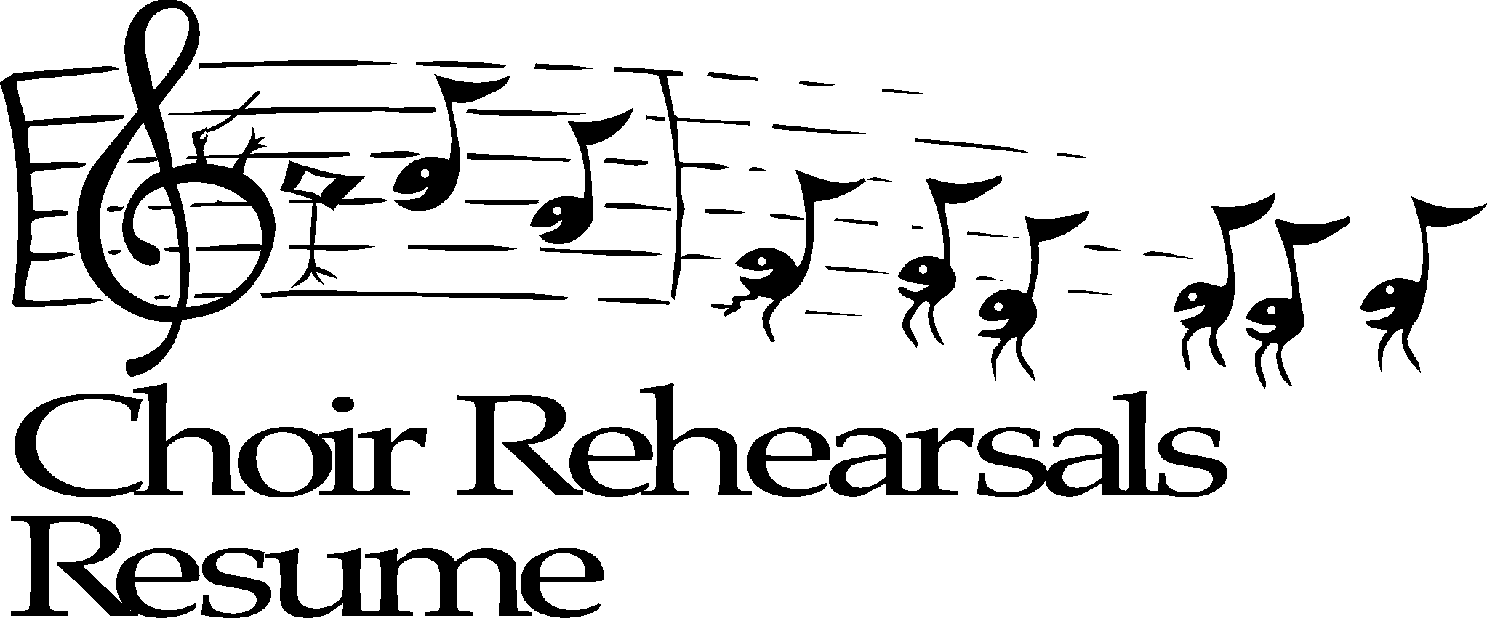

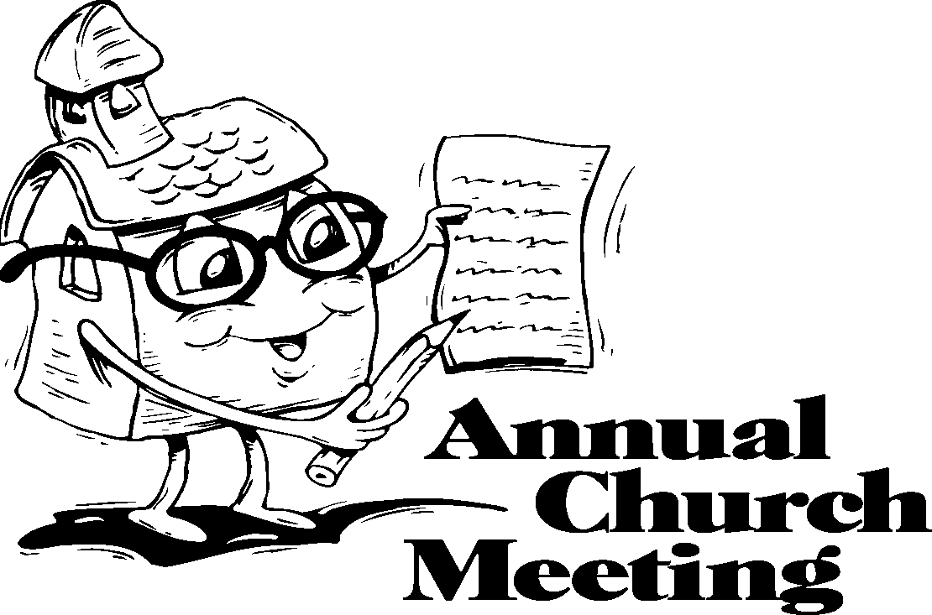

Astoria Choir Rehearsals
All are welcome to join us in the Astoria sanctuary at 6:30 pm. on Wednesdays, beginning September 2. The gift of music is a blessing. Come make a joyful noise.

Kenya Mission Team report September 12

All are invited at 11:30 am to hear Gloria Jones give a report on her June/July trip with the Volunteers in Mission team from Oregon. She will share pictures and stories. We will meet in the sanctuary in Astoria for the report and then have a salad lunch hosted by the United Methodist Women. You do not need to be a woman to attend. Sign–up sheets for salads and sign-up sheets for attendance will be posted in the Powell-Turner room to make sure we have enough food for everyone. Or, for a reservation call the church office, 503.325.5454, by September 8, 2009. A brief UMW meeting will be held at 11 am.

Astoria Adult Sunday School starts September 13
Join the adult Sunday School class on Sunday mornings at 9:45 in the Wesley Room as they resume their class September 13. All are welcome. The book that will be studied is The Psalms for Today. Don Morden is your teacher.

Joint Worship and All Church Conference September 13, 11 am
Warrenton and Astoria congregations will gather in Astoria September 13, at 11 am for a joint worship service and the annual all church conference under the direction of our District Superintendent, The Reverend Kate Conolly. We will worship, hear reports, and decide on Pastor Judy’s salary. All are encouraged to attend. Joint SPRC will meet at 10:15 am.

Warrenton Bible Study, Wednesdays, 2 pm
Everyone is welcome at the table in the fellowship hall of the Warrenton church. Jane Hill is the leader of the often spirited discussion. We use many translations and share our experiences as we study.

OPEN DOOR OUTING: Twelve clients from Open Door either bowled or cheered as we had fun at Lower Columbia Bowl during our August 3rd picnic outing. When we heard the trolley had a mechanical problem and was not running, we decided to go bowling and then back to Open Door for a picnic lunch of Kentucky fried chicken, potato salad, watermelon and homemade cookies. We ended with a sing-a-long of familiar folk songs.
Special thanks to Joanne and Denis Soderman, Anne Morden, Diane Grumbling,
Sue Hicks, and Pat Williams for helping to make this event a success.
Open Door Needs:
Special thanks to those who have donated toothpaste and toothbrushes, shampoo, soap, toilet paper and paper towels for the Open Door clients in need. Also, thanks to the UMW for providing money to purchase laundry detergent and toilet paper at special sale prices. This is a constant need for Open Door clients, so please help if you can and put your donated items in the Open Door bin in the Powell-Turner room. You are such a generous people and they so appreciate all that you share. Judy Mattson

Astoria Finance Report from Jane Hill
The Astoria First UMC Finance work group met in the last part of August and received a detailed-filled, clearly expressed report from our treasurer, Harry Comins. Based on a close comparison of financial income and outflow from 2008 and 2009, we are very happy to affirm and celebrate our congregation's constancy and generosity. Your prayerful consideration of your stewardship, commitment to giving, and actual provision of what you have promised is a wonderful contribution. You continue to give support for programs and ministries even with the reality of our national financial challenges. Thank you!!
The Finance work group also heard about the reality that there is not enough in our checking account to pay the month to month expenditures for the church. As of last week's report, our checkbook has a negative balance of more than $5,000.00. That means, currently, Harry is not able to meet the monthly expenditures without making temporary withdrawals from other accounts, including memorial funds. Work group members are making plans for a variety of fund raising activities to correct this situation, increase available money and restore the fund balances.
You will be hearing of opportunities to participate in the Garage Sale, Saturday breakfasts for the public, large events like the dinner/service auction and a community dinner. Of course, we are wanting to hear additional ideas from you, so don't hesitate to share your thoughts and dreams. Work Group members include Judy Mattson, Don Morden, Gloria Jones, Mary Frances Gunn, Harry Comins, Jane Hill and Pastor Judy.
No matter what these financial stewardship events turn out to be, we need three things from you—
1. Prayer, 2. Your supportive participation, and 3. Bringing friends and neighbors along with you to the activity.

Please Pray for
- Those with health concerns: Lori Kindred, Irene Davis, Russell Maize, Norman Downy, Sharon Wolf, Sylvia Stephens’ daughter Kate, Laurel Nichols and her son Jerry, Joy, George Gunn, Pam Jenkins, Scott Kindred, Charlie and Nellie Hansen, Maxine Dymond, Bob Tate, Carol Boothe, Pat Kujala, Carol Clark, Waletta Kempt, Delores Hodney, Ginny Bynum, Al and Verna Davis, Priscilla and Bob Gauthier, Elizabeth Mannarino, her 5 y/o grandson Leo, Jewell Smotherman, Rose Marie Thompson and her brother, our district superintendent Kate’s mom. All who are ill.
- All who are mourning, and in particular Judy Niland and the arts community of Astoria at the death of her husband, Franko Lowey.
- Our children, teachers and school staff as a new school year begins.
- Pray that peace, patience, kindness, and trust in God will replace our fears and will continue to empower us to help people in need in practical ways. Pray for us to be open to the Holly Spirit.
- Pray for the people who have lost their jobs, homes, life savings.
- Our nation’s leaders
- All the men and women serving in Afghanistan and the Middle East.
- The hungry, the homeless, those in prison, those living in violence

Special People
- The many from both churches who prayed and worked to make Day Camp so successful. The 25 children who came.
- Linda Grznar, the Astoria Administrative Assistant who did so much behind the scenes work for Day Camp
- Gerlind Wuepper for her gift of a coffee maker for the upstairs kitchen in Astoria.
- All from the Astoria church who were able to ride the trolley and gather for a picnic August 22, We were blessed with wonderful sun, good food and good fellowship.
- The many who are attending extra meetings as we prepare for our All Church Conference,
- Joanne Soderman and the women who gathered at her house for the annual UMW picnic. We were so pleased to see Dorothy and Trudy.

Getting To Know You
You are invited to the United Methodist Women’s unit meeting on October 13, 2009. at 1:00pm in the Wesley Room. We would like you to bring any special collection you have or a hobby you could share. In this way we will be “Getting To Know You Better”. Save the date and plan what you will bring to show all your friends. More information will be coming closer to the date. Questions? Call Mary Lovvold, 503-325-4703 or Anne Morden. 503-325-7527

Astoria Garage Sale October 9 and 10 – Start saving now.
Wanted: clean, good quality items for our annual fundraiser garage sale. No clothes or TV’s please. Harry will need help to set up and work on the days of the sale. Watch for a sign-up sheet.
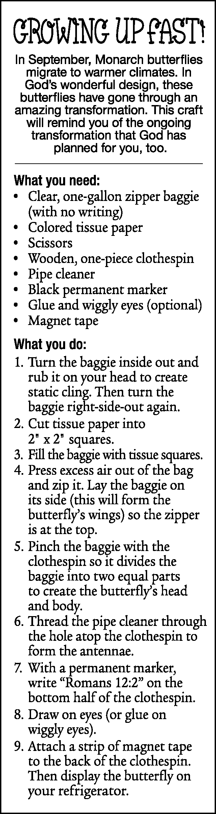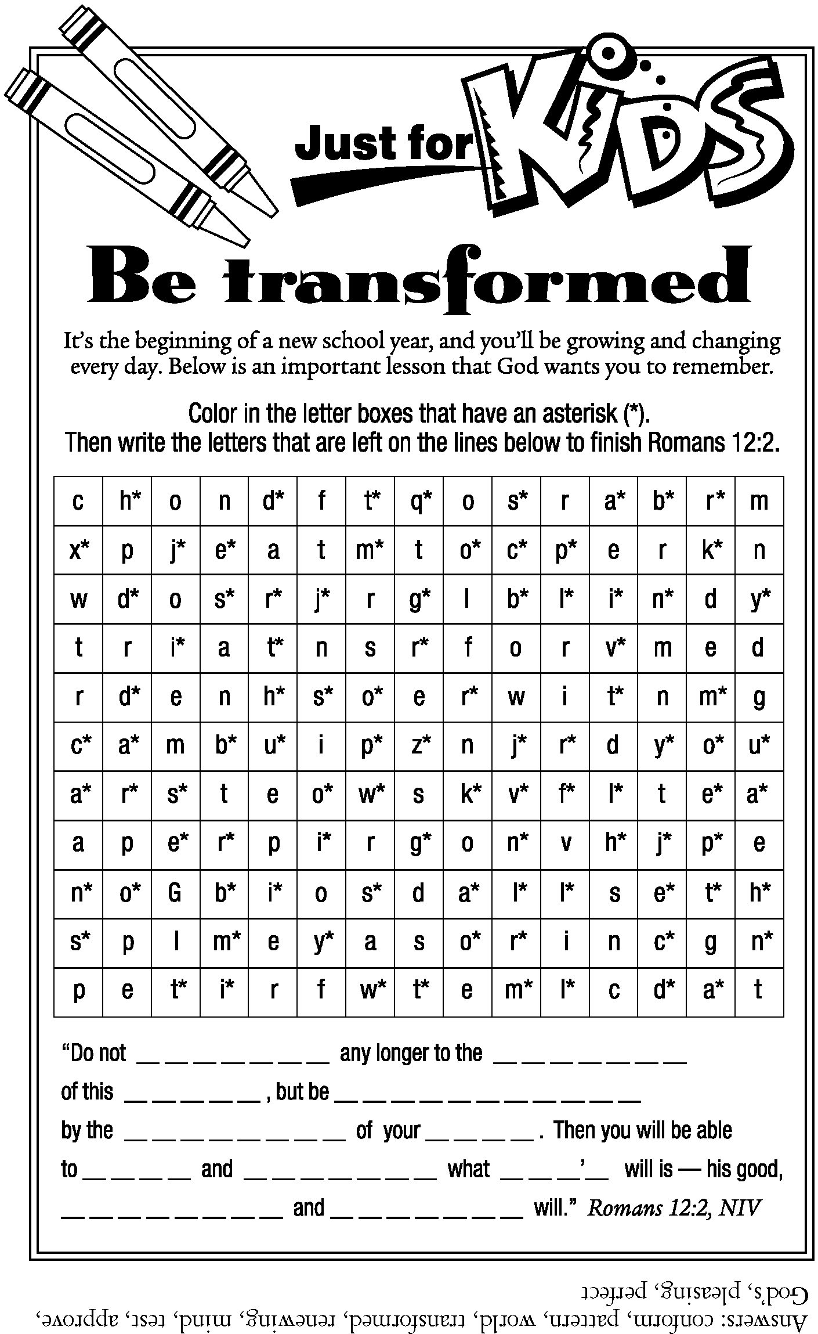

Did you know….
That the Ministry Cabinet of our annual conference reduced their salaries to the 2008 level last April? The cabinet includes our district superintendents, the Director of Stewardship and Finance, and the Director of Connectional Ministries. The Council of Bishops has also announced a salary reduction to the 2008 level for all Bishops in the United States. Please continue to pray for the church as it seeks to be good stewards of all God provides.

